ANNUAL REPORT

(01-07-2018 TO 30-06-2019)

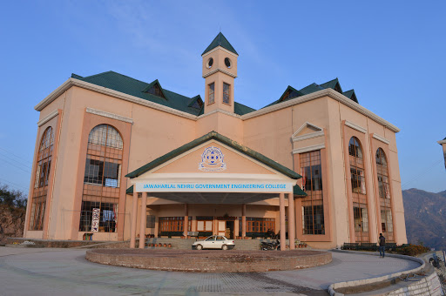

Jawaharlal Nehru Govt. Engineering College, Sundernagar, Mandi(H.P.)

TEQIP-III Project

INDEX

S.No. | Description | Page No.
 | Institutes Basic Information | 3-4
 | Vision & Mission | 5
 | Information Regarding Affiliating University | 6
 | Information Regarding Academy Autonomy | 6
 | Governance Structure & Organization Structure | 6-9
 | Academic Calendar | 10-11
 | Infrastructure: Academic, Library, Computer Centre, Residential & Hostel | 12-16
 | Department Profile with Infrastructure and facility | 16-19
 | Information Regarding NBA | 19
 | Programmes offered | 20
 | Student Strength | 21
 | Faculty & Staff Position | 22-24
 | Exam Result Analysis & Transition Rate of UG Students | 25
 | GATE Qualified Student Data | 26
 | Training Programme for Teacher and Staff | 26-29
 | Student’s internship data | 29-40
 | Placement Data | 41-43
 | R&D Achievements | 44
 | Consultancy projects in hand | 45
 | Start up and Innovations | 45
 | Linkage with Industry | 45
 | Collaborative Activities | 45-47
 | Curricular & Co-curricular Activities | 47
 | Awards Prizes by faculty /students | 47
 | Financial Information | 47
 | Internal Revenue Generated | 47

- Institute Basic Information

The Jawaharlal Nehru Govt. Engineering College Sundernagar (H.P.) is the first State Engineering College of Himachal Pradesh and was established in the year 2006 with the vision to bloom into centre of excellence and become pace setter by opting quality processes interwoven with freedom of flexibility and to mould professionals of superior quality dedicated to the progress and development of humanity. Our aim is to create and disseminate knowledge and skills in core and frontier disciplines through innovative educational programmes, industrial training, research & consultancy and develop a new cadre of professionals with a high level of competence, deep sense of social commitment and ethics. JNGEC is a leading institute offering multidisciplinary four undergraduate Bachelor of Technology programmes in Engineering.
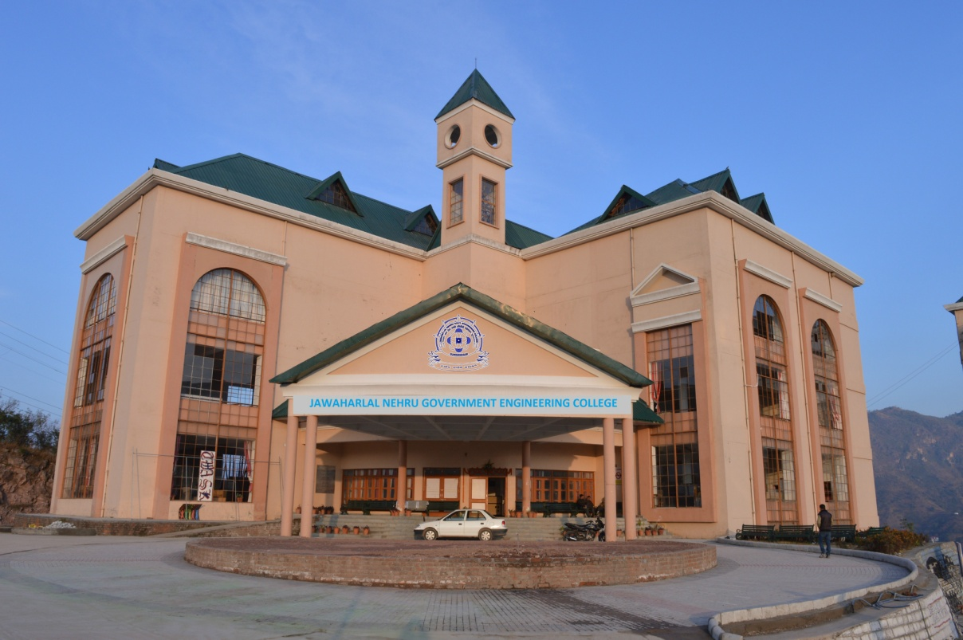

TECHNICAL AND PROFESSIONAL COURSES
After being established in the year 2006, Jawaharlal Nehru Govt. Engineering College has grown in its stature and number of courses. Today we are having 4 under graduate B. Tech. courses namely Mechanical, Civil,Textile, and Electronics and Communication Engineering. Total intake capacity in our engineering college is 240 seats in B. Tech. We have around 1000 students studying in our beautiful campus today. JNGEC is approved by AICTE and affiliated to HPTU, Hamirpur. The JNGEC has established a good brand image for its outstanding infrastructure, excellent teaching, and a very good blend of highly qualified, experienced and talented faculty. With students from different parts of Himachal Pradesh, JNGEC has become a preferred destination for admission. The institute is in the process of preparation of SAR (Self Assessment Report) of all four UG programme for NBA accreditation. This institute has highly impressive campus encompassing all the modern educational and training facilities such as modern class rooms, equipped laboratories, workshops, advanced computer lab with the latest computers. The library of JNGEC is having the membership of National Digital Library (NDL). All students and faculty members are registered with NDL, having a wide range of national and international journals, books and e-books. This institute is running under the dynamic leadership of Prof. Vinod Kumar.
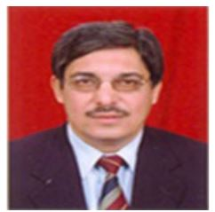
Prof. Vinod Kumar (Director-Cum-Principal)

- Vision & Mission

Our Vision
To bloom into centre of excellence and become pace setter by opting quality processes interwoven with freedom of flexibility and to mould professionals of superior quality dedicated to the progress and development of humanity.

Our Mission
- To create an environment that enables creativity, research and innovation in engineering and technology.
- To impart value based education that created leaders in engineering for up-liftment of society at large.
- To strive for continues improvement in imparting technical education.
- To have a liaison with lead institutions and industries.

Objectives
- To provide students with fundamental technical education and skills in mathematics, Science and Engineering.
- To provide students with necessary skills and practical knowledge to fulfil their professional duties and responsibilities in team work, ethics, technical leadership, business and lifelong learning.
- To make the students to become true engineers and innovators to make substantial contributions to the society.
- To prepare the students to become successful engineers and managers to meet the global industrial requirements.
- To promote the spirit of entrepreneurship among the students and foster close interaction with industries

- Information Regarding Affiliating University

Jawaharl Nehru Government Engineering College, Sundernagar is affiliated to H.P. Technical University Hamirpur.The Himachal Pradesh Technical University is established in the year 2010 by an Act of Legislative Assembly of Himachal Pradesh with an objective for value creation and welfare of society through technical education training, research, innovation, entrepreneurship and continuing education programs. At the same time, the University is responsive to the changing and exceptional requirements of our society and economy and contributes to find answers to global problems. The University offers both short-term and long-term programs leading to Advance Diploma and Degrees, which are conventional as well as innovative through public and private participation. Most of these programs have been developed after an initial survey of the demand for such Programs.

The programs offered are designed to equip graduates with the necessary skills and expertise to be the leaders in their chosen professions. The key to the success lies in the high premium it places on innovation, along with the work that is done by different role players and stakeholders to promote the University achievements in the fields of Science, Engineering and Technology. This is being achieved through a benchmarking system, which ensures that training and research programs always meet the highest standards.
- Information Regarding Academy Autonomy

Institute is not Academic Autonomous. Institute follows the academic regulations of HPTU Hamirpur.

- Governance Structure & Organization Structure

The institute being a Government Institute, is funded, regulated and administered as per the rules/regulation and instructions issued by the State Government (Department of Technical Education, Vocational & Industrial Training, Himachal Pradesh) from time to time. The Department is administered by the Additional Chief Secretary/Principal Secretary (Technical Education to the Government of Himachal Pradesh) and headed by the Director (Technical Education) and Director-cum-Principal acts as controlling, drawing and disbursing officer.
The appointment of faculty and staff is made by the recruiting agencies of the State Government i.e. Himachal Pradesh Public Service Commission and Himachal Pradesh Staff Selection Commission as per the R&P rules prescribed for various posts by the State Government. These R&P rules are published on Gazette of Himachal Pradesh and also disseminated in public through e-gazette portal of Government of Himachal Pradesh.
The Government of Himachal Pradesh also constituted Board of Governors (BOG) vide Notification No. END (TE) F (1)1/2017 Dated 18-05-2018 under “Technical Education Quality improvement Programme” (TEQIP) Phase-III. The Board is having the following members:-
Board of Governors
1. | Dr. Lalit Sharma, BTH-114, Teachers Colony, H.P. University, Summer Hill, Shimla-171005 H.P.  Contact No. 98166-01405  (Nominated by the State Govt.) | Chairperson
2. | Two faculty members to be nominated by the Director/Principal of Jawaharlal Nehru Govt. Engineering College Sundernagar, District Mandi H.P. based on seniority. | Members
3. | Sh. Jatinder Sharma C/O J.D. Traders, LalitChowk Sundernagar, District Mandi H.P.  Contact No. 94184-6605  (Eminent Educationist) Nominated by the State Govt. | Member
4. | Sh. Arun Kumar Sharma S/O Sh. Shakti Chand Kaundal Resident of Haripur, P.O. & Tehsil Sundernagar, District Mandi H.P. Contact No. 94184-96496  (Eminent Educationist) Nominated by the State Govt. | Member
5. | Sh. Shiv Singh Sen, Village Salah, P.O. Bhojpur, Tehsil Sundernagar, District MandiH.P.Contact No. 94184-84500  (Eminent Educationist) Nominated by the State Govt. | Member
6. | AICTE Nominee  (To be Nominated by AICTE) | Member
7. | Joint Director, Technical Education  (State Govt. Nominee) | Member
8. | Dean (P&D) HimTU  University Nominee | Member
9. | Director/Principal of Institution | Ex Officio Member/Member Secretary
Director-cum-Principal
AICTE
NBA

TEQIP (Coordinator)
TEQIP III
BOG
Administrative
Dean Academics
Dean P&D
Dean (SW)
TPO
SPO
Librarian
Supdt. Grade I
JC(F&A)
Other Staff
Other Staff
Other Staff
Other Staff

Other Staff

Other Staff

SO F&A
Hon’ble Minister
(Technical Education, HP)
ACS / Pr. Secretary Technical Education
Special Secretary Technical Education
Director ndustrial Technical Education & Vocational and ITraining (HP)

Joint Director
Dy. Secretary Technical Education
Estate Office
Vehicle Section
Nodal Officer Land
GHS
NCC
NSS
HOD’s
Mechanical Engineering
Textile Engineering
Electronics and Communication Engineering
Civil Engineering
Technical Staff
Departmental Faculty
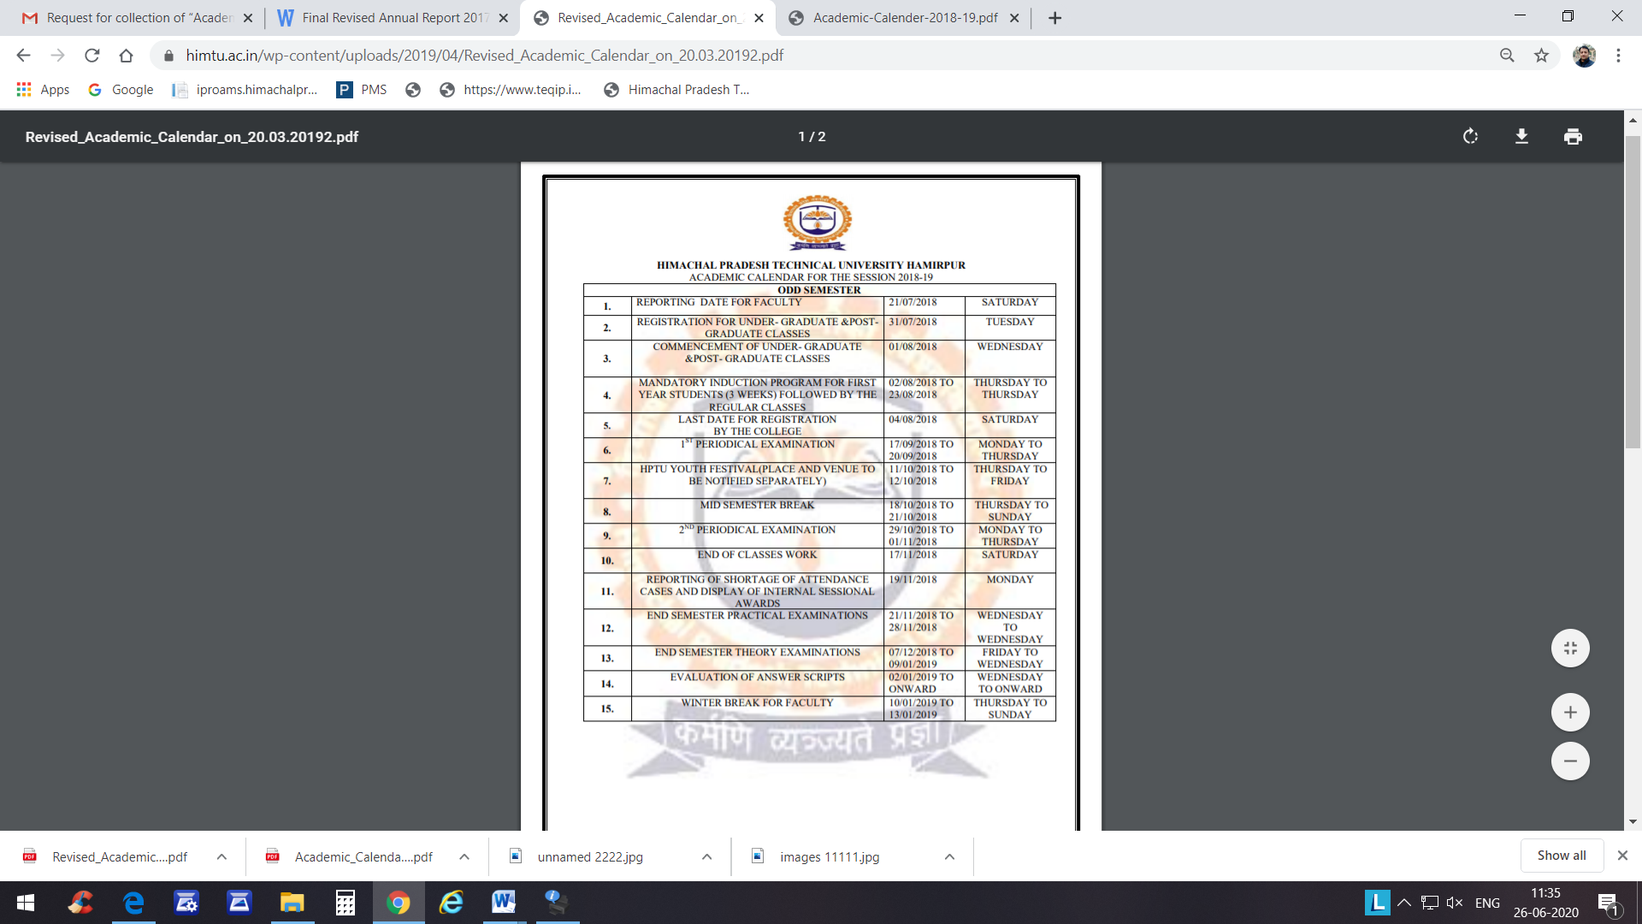
- Academic Calendar

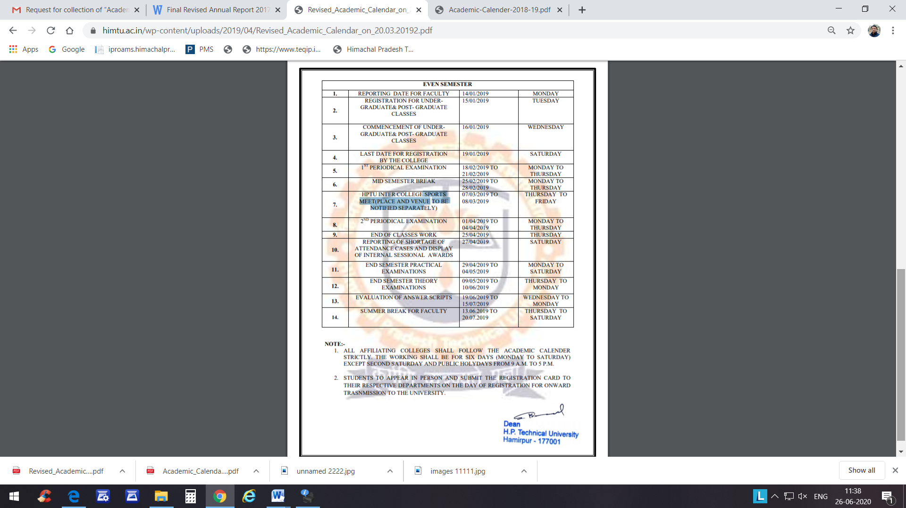

- Infrastructure: Academic, Library, Computer Centre, Residential & Hostel

Academics

The College Currently offers 4 year Bachelors of Technology (B.Tech.) courses in four disciplines, namely:
- Electronics & Communication Engineering (ECE) (60+3* Seats)
- Civil Engineering (CE) (60+3* Seats)
- Mechanical Engineering (ME) (60+3* Seats)
- Textile Engineering (TE) (60+3* Seats)
3 seats are reserved for Tution Fee Waiver Scheme (TFWS).All these Programmes are affiliated to Himachal Pradesh Technical University Hamirpur

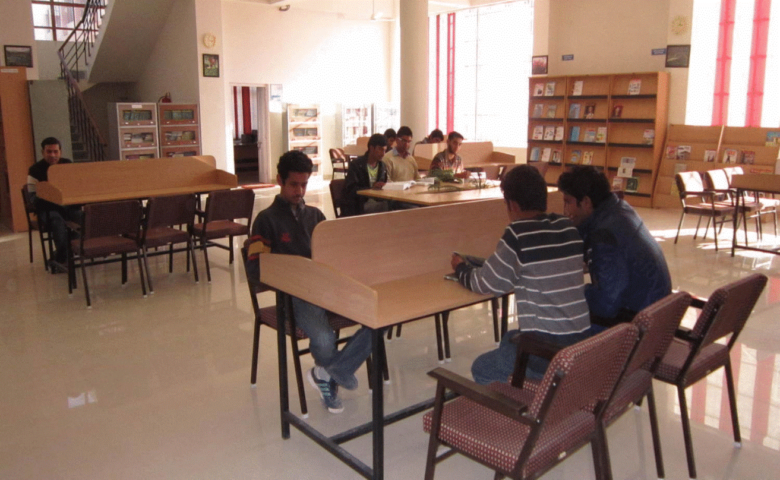
Central Library

The central library at Jawaharlal Nehru Government Engineering College,Sundernagar (JNGEC) was set up in the year 2006 in the campus of Govt. Polytechnic library sundernagar. It was shifted to the college campus in the year 2011. The library is situated in Administrative Block A and is comprising of the three floors of the block. The library has got the seating capacity of 60 readers.

Collection
S.No | Name of Items | Quantity
1 | Total numbers of Books | 10048
2 | Total numbers of Titles | 2050
3 | Total numbers of Journals | 22
4 | Total numbers of Magazines | 19
5 | Total numbers of Newspapers | 7
6 | Seating Capacity | 250
7 | Photostat Facility | 1
8 | E-Library | 20 Computers
9 | Wi-Fi Facility | Available
10 | E-Journals | 1. ASTM Digital Library  2. Springer 586 Journals  3. J-Gate Engineering & Technology

Computer Centre
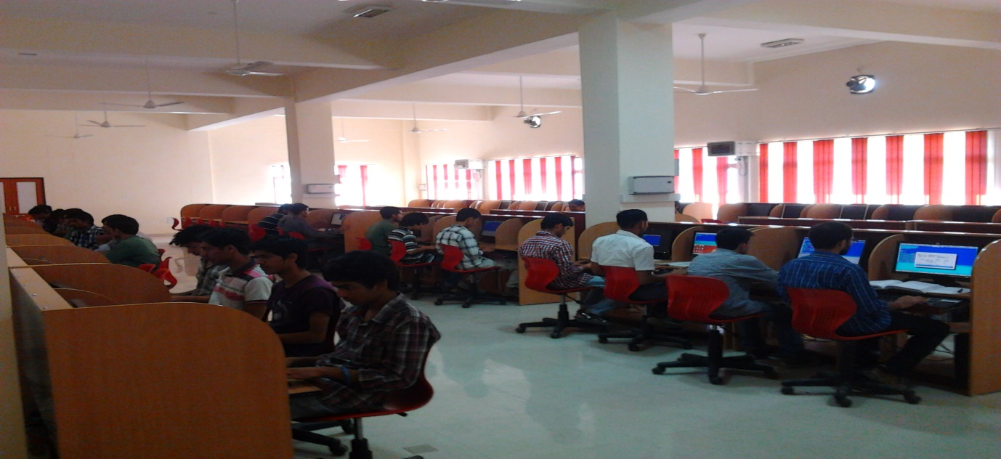
Established in 2010, JNGEC Computer Centre serves the college as its central computing facility and the nodal centre for computer activities on the campus.The Centre supports and coordinates computer usage by Graduate students, faculties and staff of various departments. The centre provides guidance, support and services to the faculties and staff of various departments and academic institutions in performing statistical analysis for their work.Computer Centre is entrusted with the responsibility of promoting the IT infrastructure, Network and Automation in the college. The department is involved in conducting various activities like workshops, Web development trainings etc. The Computer Centre is encouraging the use of open source software's.

Infrastructure
Currently the Centre is equipped with with latest configuration dual boot computer systems loaded with relevant software systems. Student works with Windows and Linux based computer systems. Computing nodes are well connected with 100 mbps high speed internet connectivity.
Computer Centre is a central facility, which caters the needs of all four disciplines and various sections of the institute. This Centre is well equipped with the latest configuration Computer systems with Network printer and relevant software's. All the Blocks are connected with Wi-Fi Networks.Computer Centre and Central server systems with 100 Mbps NKN Connectivity with a capacity of 80 students had been catering to the needs of various stakeholders of this institute.

Smart Classroom
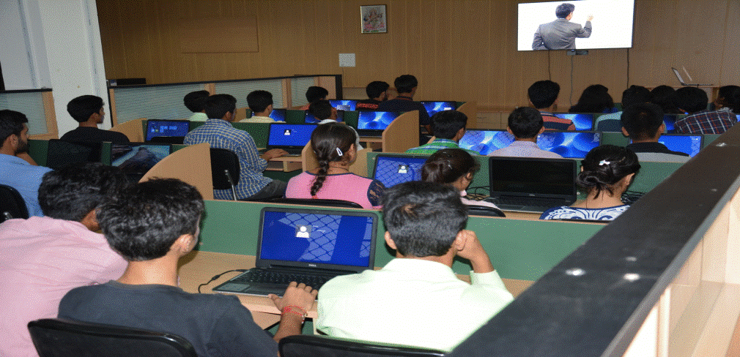

Smart classrooms are Technology Enhanced classrooms that integrate the learning with latest technological tools. Such classrooms enhance the quality of teaching. To provide best quality education using latest technology, the institute has taken the initiative in this direction. The task of development of smart classroom is completed.The advent of Information and Communication Technology has had a profound and commanding global influence on the matrix of socio-economic and educational activities the world over in new era. Industrial and developed countries are well-ahead in formulating policies and programmes to accelerate its development, diffusion and empowerment abilities. Developing countries like India, having sensed it, follow at a breakneck velocity for establishing and capitalizing on the enabling capabilities of Information and Communication Technology in the field of Education. Technology was very ancient to India which gave to the world the binary system on which modern education and computer systems are based.
Learning and dissemination of information is becoming more important than ever. Internet based education and e-Learning are the trends of the day. Looking at India’s attempts to harness the broadcast technologies, one comes across a kaleidoscope of activities. India is perhaps the only country with a satellite completely dedicated to education, the EDUSAT. India has developed educational broadcast channels such as the GyanDarshan Network and dedicated satellites such as EDUSAT for audio, video and data transmission and interactivity. India has 17 Education Multimedia Research centres and coordination centre Consortium of Educational Communication which helped building considerable knowledge resources over a period of 20 years.
Canteen
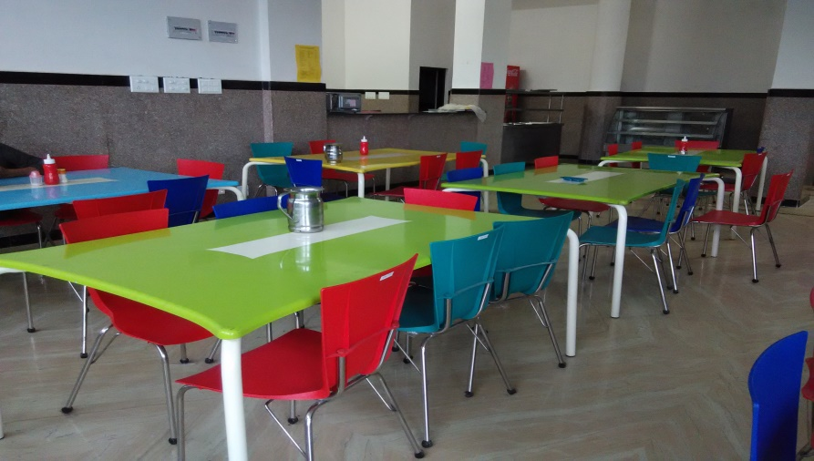
The college canteen is a spacious food joint newly constructed for the purpose of serving wholesome, nutritious food to the JNGECians. The canteen is situated in the D-block ground floor and remains open from 9.00 A.M. to 6.00 P.M. on all working days. A wide variety of Indian snacks and dishes are available. During lunch time, meals are available at very reasonable prices. The canteen besides being hygienic also provides swift service. The ever-busy canteen bustling with inquisitive minds is a recreational -cum-hangout place for the members of JNGEC family.

Conference Hall
The college has the conference hall with the capacity of 100 participants. The conference hall is located in second floor of Administrative block 'A' of the institute. The conference hall has ultra-modern infrastructure with high quality sound system. The conference hall is planned to be provided the high speed internet connectivity and video cameras to make two way on-line communications possible with remote nodes.
Hostel Facilities
Boy’s hostel is under construction and will be started from next semester.

- DEPARTMENT PROFILE

Department of Mechanical Engineering
The Mechanical Department was started in 2006 with an intake of 60 students. The department has well qualified and dedicated faculty. The faculty members give the students a hands-on approach in the use of Engineering principles and the opportunity to develop creative approaches to problems. The objective of the department is to prepare students for successful career in industry, research and academics to meet the need of growing technology. We provide opportunity for students to work as members of a team on multidisciplinary projects. The available equipments, excellence in instruction and an emphasis on quality of education in Mechanical Engineering combined together to prepare the students to step into positions of responsibility at the leading edge of today’s technology. The Mechanical Engineering student with a desire to learn will develop and expand his or her knowledge and skills in the areas of engineering sciences, testing techniques, material properties, analysis and evaluation along with communication. For the overall development of student, Department of Mechanical Engineering is associated with memberships of professional bodies. Various technical activities of these chapters provide students to gain knowledge and interact with the students and staff of other Colleges/ Universities as well as Industry Engineers. Students of Mechanical Engineering Departments have taken parts in various academics as well as co-curricular activities/competitions and secured positions. Our graduates are working in multinational companies, defence services and academic institutions in various parts of India. Today JNGEC has grown in all directions and has become a distinguished centre for modern learning.

Department of Textile Engineering
Himachal Pradesh, situated in the foothills of the Himalayan mountain ranges, has emerged as hub of Textiles and developed rich traditions of handicrafts made up of Wool, Pashmina and Silk.To harness this abundant potential in the Textile industry in Himachal Pradesh, Textile Engineering department at Jawaharlal Nehru Govt. Engineering College Sundernagar (H.P) was established in 2006 which is only of its kind in the state. The department offers Bachelor of Engineering in Textile Engineering with aim to generate a horde of highly creative textile professionals impacting the society at large.The textile engineering department at J.N.G.E.C, Sundernagar has specialized faculties in all important areas of textile engineering such as fibre, spinning, weaving, processing, testing and designing. It is well-equipped with facilities in its laboratories to provide ample opportunity to the students to explore their penchant for learning and innovation.

Department of Electronics and Communication Engineering
The department of Electronics & Communication Engineering was established in 2010.It offers Under Graduate courses (B.Tech) in the field of Electronics & Communication Engineering. It has a supportive campus environment where one can actively collaborate with his/her faculty and classmates as well as get involved in the other innovative things.The Department provides many opportunities to gain practical work experience and ensure a successful career. Electronics engineers are changing the world to a comfortable global home. The information and technology revolution has been built on the advances of Electronics. E&CED is making exhilarating progress in areas ranging from satellite communication, wireless communication microelectronics to VLSI Design Automation. In labs and classrooms, students draw on the expertise and knowledge of our able faculty, Integrating practical, hands on research experience with challenging and interesting course work.

Department of Civil Engineering
Civil Engineers are the builders of modern world and are instrumental in creating the monuments of modern technology. Due to the increased emphasis on the development of infrastructural facilities especially in the country like India, civil engineers are required to play a major role in creating better and improved infrastructural facilities for the mankind.
However, to achieve this target, civil engineers are required to be equipped with latest technical know and should be capable enough to tackle the constructional site challenges. The Civil Engg.branch in the JawaharlalLalGovt. Engg. College Sundernagar Mandi (H.P.) has been started since the year 2010. The Civil Department has augmented various laboratoriesand other facilities keeping in view the contemporary technological advancement in the constructional industry. Department also conducts Industrial training and survey camps to make the students familiar about the actual working site practices. Beside this, a special care undertaken to develop the soft skill among the students. Civil Engg. Department is moving forward to become a centre of excellence in the field of Civil Engineering and as a source of learning& support to the students and community.

Department of Applied Science and Humanities
The Department of Applied Sciences and Humanities is established to strengthen the basic and practical requirements of an engineer in the field of natural sciences, society and communication as well as to produce good human beings. The engineers produced from this college will not only be perfect in the concepts of engineering only but they must possess managerial skills, which are most required nowadays. When he joins any organisation or joins a group of people working together, must interact with people around him in order to share his needs, thoughts, plans, expertise, operations and so on. So he or she should be very excellent in their communication skill. Whatever they do in their working area they must keep and carry good humanity approach for the betterment of society and nation as a whole. They must know how to manage things and practically they have to manage the manpower, inventory, and hierarchical set up of an organisation as well as finance which mainly affect the total scenario.Moreover natural sciences are the backbone of Engineering field and whatever an engineer does is based upon the basic principles in the field of natural sciences i.e. Physics, Mathematics, Chemistry, Environmental Science. The department of Applied Sciences & Humanities consists of Chemistry, Mathematics, Physics, English, Management, Economics and Environmental sciences.
The department has well equipped labs for imparting practical knowledge to the students in the field of Natural Sciences. Though, the institution is still in upcoming stage yet emphasis is laid upon to acquire the state of art infrastructure for the physics and chemistry labs. Under the dynamic leadership of Dr. Vinod Kumar, the faculty of Basic Sciences are leaving no stone unturned to provide the best equipment and practical knowledge to the students of this college.

- Information Regarding NBA Accreditation

Institute has submitted SARs for all 04 branches and fee for the same has also been paid to NBA. NBA visit is pending.

- Programme/Courses Offered

The College Currently offers 4 year Bachelors of Technology (B.Tech.) courses in four disciplines, namely:
- Electronics & Communication Engineering (ECE) (60+3* Seats)
- Civil Engineering (CE) (60+3* Seats)
- Mechanical Engineering (ME) (60+3* Seats)
- Textile Engineering (TE) (60+3* Seats)
3 seats are reserved for Tution Fee Waiver Scheme (TFWS).All these Programmes are affiliated to Himachal Pradesh Technical University Hamirpur

- Student Strength
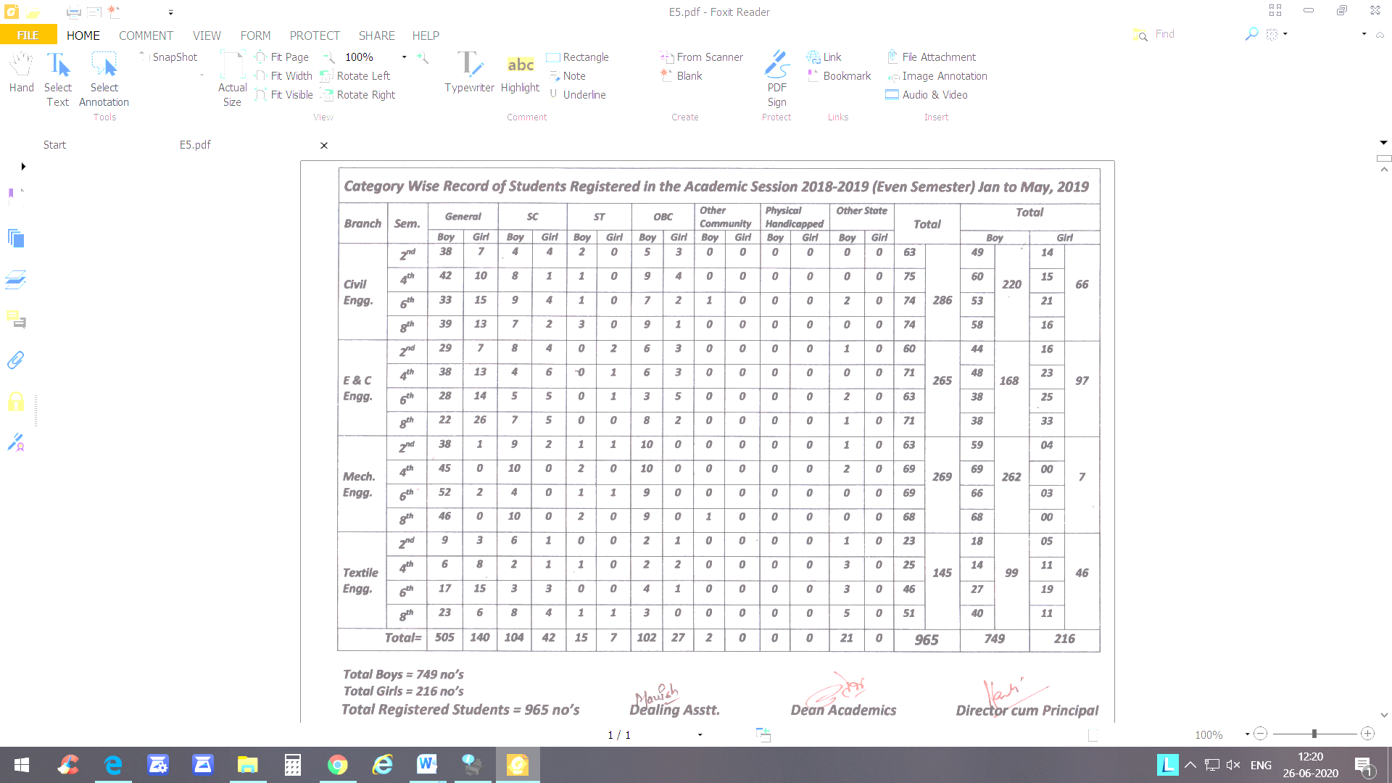
- Faculty & Staff Position

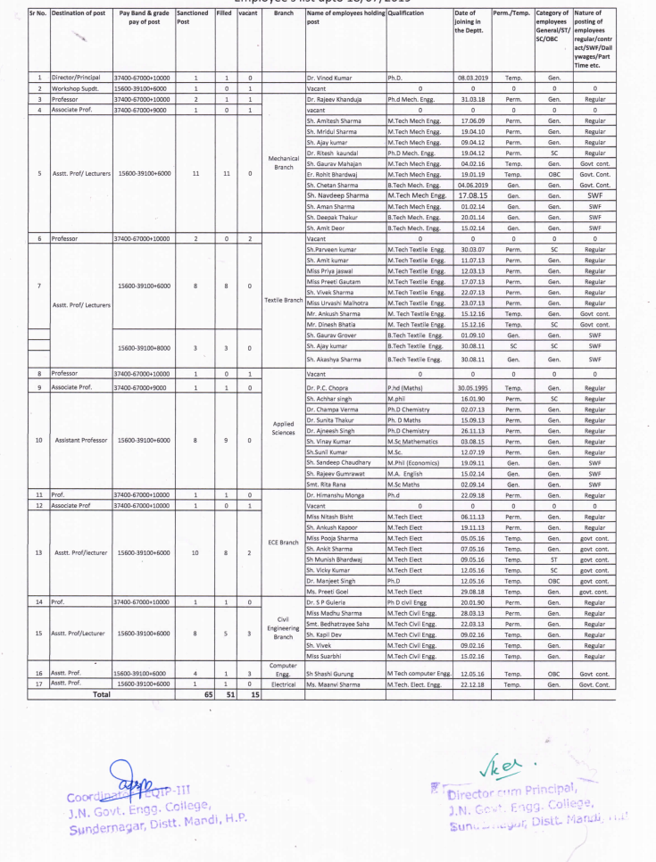

Faculty Position Consolidated

Sr. No. | Department | Professor | Associate Professor | Assistant Professor (Regular, Contract, Hourly Basis) | Total
1 | Director | 01 | -- | -- | 01
2 | Civil Engineering | 01 | -- | 05 | 06
3 | Electronics& Comm. Engineering | 01 | -- | 08 | 09
4 | Mechanical Engineering | 01 | -- | 11 | 12
5 | Textile Engineering | -- | -- | 11 | 11
6 | Applied Sciences and Humanities | -- | -- | 09 | 09
7 | Computer & Electrical | -- | -- | 02 | 02
8 | Librarian | -- | -- | 01 | 01
Total |  | 04 |  | 47 | 51

NON-TEACHING STAFF
Sr. No. | Particular | Total
1 | Administrative Staff&Technical Supporting Staff | 38
4 | Attendant, Peon & Other Staff | 9
 | Total | 47

Representation of Male to Female Faculty (Gender Ratio):
Sr. No. | Department | Male | Female | Total
1 | Director | 01 | -- | 01
2 | Civil Engineering | 03 | 03 | 06
3 | Electronic and Communication Engineering | 06 | 03 | 09
4 | Mechanical Engineering | 12 | -- | 12
5 | Textile Engineering | 08 | 03 | 11
6 | Applied Sciences and Humanities | 06 | 03 | 09
7 | Computer & Electrical | 01 | 01 | 02
8 | Librarian | -- | 01 | 01
Total |  | 37 | 14 | 51

Faculty with Ph.D. Qualification:

Sr. No. | Department | Name of Faculty | Specialization | Year of Completion
 | Civil Engineering | Dr. S.P. Guleria | Civil Engineering | 2014
2. | Mechanical Engineering | Dr. Rajeev Khanduja | Mechanical Engineering | 2010
3. | Mechanical Engineering | Dr. RiteshKaundal | Mechanical Engineering | 2011
4 | Electronics and Communication Engineering | Dr. HimanshuMonga | Electronics and Comm. Engineering | 2014
5. | Applied Science and Humanities | Dr. P.C. Chopra | Mathematics | 2011
6. | Applied Science and Humanities | Dr. Ajnesh Singh | Chemistry | 2012
7. | Applied Science and Humanities | Dr. ChampaVerma | Chemistry | 2005
8. | Applied Science and Humanities | Dr. SunitaKumari | Mathematics | 2008

Faculty Enrolled for Ph.D.:
Sr.  No. | Department | Name of Faculty | Specialization | University/ Institute
1. | Civil Engineering | Ms. MadhuGautam | Civil Engg. | Thaper University, Patiala
1. | Civil Engineering | Sh. Vivek | Civil Engg. | NIT, Hamirpur
2. | Mechanical Engineering | Sh. Amitesh Sharma | Mech. Engg. | NIT, Hamirpur
2. | Mechanical Engineering | Sh. Mridul Sharma | Mech. Engg. | Lovely University
3. | Electronics and Comm. Engg. | Sh. Vicky Kumar | ECE | NIT, Hamirpur
3. | Electronics and Comm. Engg. | Sh. ShashiGurang | CSE | NIT, Hamirpur
3. | Electronics and Comm. Engg. | Smt. NitashaBisht | ECE | Lovely University
3. | Electronics and Comm. Engg. | Sh. Ankush Kapoor, | ECe | NPU Dehrudhun
4. | Textile Engineering | Sh. Dinesh Bhatia | Textile Engg. | NIT, Hamirpur
4. | Textile Engineering | Sh. Ankush Sharma | Textile Engg. | NIT, Hamirpur
5. | Applied Sciences and Humanities | Sh. Desh Raj | Physics | HPU, Shimla

- Exam Result Analysis/Transition Rate

Transition Rate List of 2nd Sem. students admitted during last academic year (2018-19) along with result (without backlog) 2019--20.
Branch | 1st Year to 2nd year (2018-19) | Male | Female | SC |  | ST |  | Gen |  | OBC |  | Pass (Without Backlog)
 |  |  |  | M | F | M | F | M | F | M | F
Civil | 63 | 49 | 14 | 02/04 | 04/04 | 00/02 | 00/00 | 20/38 | 06/07 | 02/05 | 03/03 | 37/63= 58.73%
ECE | 60 | 44 | 16 | 01/08 | 01/04 | 00/00 | 00/02 | 11/29 | 03/07 | 02/06 | 01/03 | 20/60= 33.33%
Mech. | 63 | 59 | 04 | 03/09 | 02/02 | 00/01 | 01/01 | 23/38 | 01/01 | 01/10 | 00/00 | 31/63= 49.20%
Textile | 23 | 18 | 05 | 01/06 | 00/01 | 00/00 | 00/00 | 00/09 | 00/03 | 01/02 | 00/00 | 02/23= 08.69%
Total= | 209 | 170 | 39 | 07/27 | 07/11 | 00/03 | 01/03 | 54/114 | 10/18 | 06/23 | 04/06 | 90/209= 43.06%
Result SC students =15/38=39.47%
Result SC students =01/06=16.66%
Overall SC/ST students result= 36.36%
Overall Result of JNGEC, Sundernagar in 1st year = 43.06%
HPUT Result Overall= 30.90% in 2nd semester

- GATE Qualified Student Data

Sr.No | Discipline | No of Students Qualified Graduate Aptitude Test Engineering Examination
Sr.No | Discipline | GATE-2019 | GATE-2018 | GATE-2017 | GATE-2016
1 | Mechanical Engineering | 06 | 06 | 10 | 13
2 | Textile Engineering | 02 | 02 | 07 | 08
3 | Electronics and Communication Engineering | 04 | 01 | 05 | 07
4 | Civil Engineering | 14 | 03 | 06 | 07
Total |  | 26 | 12 | 28 | 35

- Training Programme for Teacher and Staff

Sr. No. | Name & Designation | Date | Topic | Place
 | Dr. ChampaVerma, Assistant Professor | 16-27th July, 2018 | “Research Methodology “ | NITTTR, Chandigarh
 | Er. NitashaBisht, Assistant Professor ECE | 16-27th July, 2018 | “Research Methodology “ | NITTTR, Chandigarh
 | Er Amitesh Sharma, Assistant Professor Mechanical | 16-27th July, 2018 | “Research Methodology “ | NITTTR, Chandigarh
 | Er. Mridul Sharma, Assistant Professor Mechanical | 16-27th July, 2018 | “Research Methodology “ | NITTTR, Chandigarh
 | Er. Ajay Kumar, Assistant Professor Mechanical | 16-27th July, 2018 | “Research Methodology “ | NITTTR, Chandigarh
 | Er. BedatrayeeSaha Assistant Professor Civil | 20-26th July, 2018 | 07 Days Faculty Development Programe For Student Induction Program | SantLongowal Institute Of Engineering And Technology (SLIET) Longowal (Pb),
 | Er. UrvashiMalhotra Assistant Professor Textile | 20-26th July, 2018
 | Er. GauravMahajan Assistant Professor Mechanical | 20-26th July, 2018
 | Er. Ankit Sharma Assistant Professor ECE | 20-26th July, 2018
 | Prof. Raman Parti, Director /Principal | 14-15th July, 2018 | TEQIP-III: Training Programme On Financial Management And PFMS | UIET Chandigarh
 | Sh. Ajay Kumar, Nodal Officer Procurement | 14-15th July, 2018 |  | UIET Chandigarh
 | Dr. P.C. Chopra, Head AS&H | 19th November, 2018 | workshop on Equity Action Plan | PEC, Chandigarh
 | Prof. Rajeev Khanduja, Head Mechanical | 27-29th December, 2018 | Paper presentation in 9th International Conference on Quality, Reliability, Infocom Technology and Business Operations” | University of Delhi, Delhi
 | Prof. HimanshuMonga, Head ECE | 3-5th January, 2019 | STC on “Academic Leadership Development Programme” | IIT Bombay
 | Sh. Ankush Kapoor, Assistant Professor ECE | 3-6th January, 2019 | MATLAB project course on “Massive MIMO and Millimeter wave (mm wave) MIMO Technologies” | IIT Kanpur.
 | MsUrvashiMalhotra, Assistant Professor, Textile Engg. | 18-20th January, 2019 | 3 days Residential workshop on Universal Human Values & Ethics | IIT Mandi
 | Mr. Dinesh Bhatia, Assistant Professor, Textile Engg. | 18-20th January, 2019 |  | IIT Mandi
 | Prof. S.P. Guleria, Head (Civil Engineering Department) | 1st February, 2019 | One day workshop on Good Governance | Lucknow
 | Sh. Ajay Kumar, Assistant Professor, Mechanical Engineering  & Nodal Officer Procurement (TEQIP) | 1st February, 2019 | One day workshop on Good Governance | Lucknow
 | Dr. RiteshKaundal, Assistant Professor, Mechanical Engineering  & Dean Academics/Nodal Officer Academic (TEQIP) | 1st February, 2019 | One day workshop on Good Governance | Lucknow
 | Sh. Ravinder Sharma, Supdt. Grade-I | 1st February, 2019 | One day workshop on Good Governance | Lucknow
 | Sh. MunishBhardwaj, Assistant Professor, ECE | 5th March, 2019 | SLA orientation workshop | AICTE Auditorium Delhi
 | Dr. Rajeev Khanduja, Professor Mechanical Engg Department | 17-19th March, 2019 | “Energy, Power and Environment (IWEPE 2019)” | NIT Kurukshetra
 | Prof. S.P. Guleria, Head Civil and attended w.e.f 6- | 10th May, 2019 | Professional Development Training | atIIM Kashipur.
 | Dr. RiteshKaundal , AP ME | 10th May, 2019 | Professional Development Training | atIIM Kashipur.
 | Sh. Ajay Kumar, Assistant Professor, Mechanical | 13th May, 2019 to 14th July, 2019 | Summer Faculty Research Fellow Programme (SFRF-2019) | IIT Delhi.
 | Sh. Parveen Kumar, Assistant Professor, Textile Engineering | 22nd -26th May, 2019 | 01 week short term course on “Advancements in Garments Technology” | NIT Jalandhar
 | Prof. Vinod Kumar, Director/Principal | 29th May, 2019 | interaction meeting | New Delhi
 | Sh. Parveen Kumar, TEQIP Coordinator | 29th May, 2019 | interaction meeting | New Delhi
 | Prof. S.P. Guleria, Head | 17-21st June, 2019 | workshop for Master Trainers on “Earthquake Resistant Constructions” | Central Building Research Institute (CBRI) Roorkee
 | Ms. Madhu Sharma, Assistant Professor | 10-14th June, 2019 |  | Central Building Research Institute (CBRI) Roorkee
 | Ms. BedatrayeeSaha, Assistant Professor | 10-14th June, 2019 |  | Central Building Research Institute (CBRI) Roorkee
 | Ms. Surbhi Sharma, Assistant Professor | 10-14th June, 2019 |  | Central Building Research Institute (CBRI) Roorkee
 | Sh. KapilDev, Assistant Professor | 10-14th June, 2019 |  | Central Building Research Institute (CBRI) Roorkee
 | Sh. Vivek, Assistant Professor | 10-14th June, 2019 |  | Central Building Research Institute (CBRI) Roorkee
 | Prof. Rajeev Khanduja, Head Mechanical | 4th June, 2019 | Outcome Based Education” | HPTU Hamirpur
 | Sh. Parveen Kumar, TEQIP Coordinator | 10th June, 2019 | Meeting on installing JIO WiFi services | New Delhi

- Student’s internship data
334 students of our institution has done their internship in various institutions
S.No. | StudentName | EnrollmentNo | InstituteName | No Of Days
1 | VIRENDER SHIVAY | 1612613111 | (IL&FS) NEAR GHAGAS | 42
2 | SACHIN KUMAR | 1612613108 | (IL&FS) NEAR GHAGAS | 42
3 | AKHIL KUMAR | 10BTD5090053 | AARTI INTERNATIONAL LTD. CHANDIGARH ROAD LUDHIANA | 42
4 | SAGAR KUMAR | 10BTD5090032 | AARTI INTERNATIONAL LTD. CHANDIGARH ROAD LUDHIANA | 42
5 | PRADEEP SHARMA | 10BTD5060138 | ALLSOFT SOLUTIONS & SERVICES PVT LTD MOHALI | 42
6 | NISHANT BHARDWAJ | 10BTD5090023 | ANANT SPINING MILLS PLOT-1 INDUSTRIAL AREA MANDIDEEP M.P | 42
7 | TARUN KUMAR | 10BTD5060162 | APTRON SOL. PVT. LTD NOIDA U.P | 42
8 | HARSH DEEP | 10BTD5060124 | APTRON SOL. PVT. LTD NOIDA U.P | 42
9 | ANSHUL DHIMAN | 10BTD5060116 | APTRON SOL. PVT. LTD NOIDA U.P | 42
10 | VAIBHAV BHANOT | 10BTD5090040 | ARISHT SPINING MILLS, BADDI H.P | 42
11 | GAURAV JARYAL | 1612614403 | ASAHI INDIA GLASS LTD, NH | 42
12 | PARVINDER SINGH | 1612614405 | B.B.M.B SUNDERNAGAR | 42
13 | AKSHAY SHARMA | 10BTD5020265 | B.B.M.B SUNDERNAGAR | 42
14 | IQWAL SINGH | 10BTD5020286 | B.B.M.B TALWARA | 42
15 | POONAM DEVI | 1612613609 | B.S.N.L. HAMIRIPUR | 42
16 | CHANDERJEET SINGH | 10BTD5010297 | BAIRA SIUL POWER STATION, NHPC LTD, SURANGANI, DHAR DISTT. CHAMBA | 42
17 | SUSHANT BHARDWAJ | 10BTD5090062 | BANSAL SPINING MILL VILL BILGA LUDHIANA | 42
18 | SUMIT THAKUR | 10BTD5090048 | BANSAL SPINING MILL VILL BILGA LUDHIANA | 42
19 | SANDEEP KUMAR | 10BTD5090033 | BANSAL SPINING MILL VILL BILGA LUDHIANA | 42
20 | NITISH SHARMA | 10BTD5090024 | BANSAL SPINING MILL VILL BILGA LUDHIANA | 42
21 | ROHIT KUMAR | 10BTD5010328 | BHAKRA DAM BBMB NANGAL PB | 42
22 | RISHABH SHARMA | 10BTD5060143 | BHARAT ELECTRONICS LTD PANCHKULLA | 42
23 | AKASH BHARGAV | 10BTD5020262 | BHEL HRDC (JHANSI) | 42
24 | PANKAJ | 10BTD5020296 | BHEL HARIDWAR 299403 | 42
25 | HARSHIT SHARMA | 10BTD5020284 | BHEL HARIDWAR 299403 | 42
26 | RAJESH CHANDEL | 10BTD5020302 | BHEL HARIDWAR 299403 | 42
27 | ARVIND SHARMA | 10BTD5020273 | BHEL HARIDWAR 299403 | 42
28 | ABHISHEK SIMER | 10BTD5020261 | BHEL HARIDWAR 299403 | 42
29 | SHUBHAM CHOUDHARY | 10BTD5020313 | BHUSHAN STEEL LTD, SAHIBABAD INDUSTRIAL AREA GHAZIABAD UP | 42
30 | TARUN KHARWAL | 10BTD5090045 | BIRLA TEXTILE MILLS SAI ROAD, BADDI DISTT. SOLAN | 42
31 | SHUBHAM THAKUR | 10BTD5090038 | BIRLA TEXTILE MILLS SAI ROAD, BADDI DISTT. SOLAN | 42
32 | VISHAL SHARMA | 10BTD5020318 | BLUE STAR LTD,KALA AMB | 42
33 | SACHIN SHARMA | 10BTD5020308 | BLUE STAR LTD,KALA AMB | 42
34 | SACHIN CHANDEL | 10BTD5020307 | BLUE STAR LTD,KALA AMB | 42
35 | PUNEET CHAUHAN | 10BTD5020297 | BLUE STAR LTD,KALA AMB | 42
36 | ROHIT SHARMA | 1612614408 | BSL DIVISION -1 BBMB SUNDERNAGAR | 42
37 | RAKESH KUMAR | 1612614407 | BSL DIVISION -1 BBMB SUNDERNAGAR | 42
38 | MANISH KUMAR | 1612614404 | BSL DIVISION -1 BBMB SUNDERNAGAR | 42
39 | SONIA | 1612613611 | BSNL SHIMLA | 42
40 | SHIVALI SHARMA | 02BTD5060048 | CBITSS (UNIT OF SUKRALA IT SERVICES PVT LTD. SEC-34A CHANDIGARH | 42
41 | MEENAXI THAKUR | 10BTD5060132 | CDAC AJIT SINGH NAGAR MOHALI | 40
42 | KAVYA KATOCH | 10BTD5060129 | CDAC AJIT SINGH NAGAR MOHALI | 42
43 | RISHI KANT THAKUR | 10BTD5020305 | CENTAL INSTITUTE OF HAND TOOLS G.T ROAD,BYE PASS,JALANDHAR 144001 | 42
44 | VISHAL THAKUR | 1612614412 |  | 42
45 | PANKAJ SINGH | 10BTD5020295 |  | 42
46 | RAJAN JASWAL | 10BTD5020300 |  | 42
47 | ANUBHAV RAI | 10BTD5020272 | CO ORDINATOR , VT CELL BHEL HARIDWAR | 42
48 | MANEESHA | 1612613607 | DGM (C&I MAINT.) NTPC L:TD KOLDAM DISTT. BILASPUR | 42
49 | RAM BAHADUR | 10BTD5020303 | DIESEL LOCOMOTIVE WORKS VARANSI | 42
50 | RISHABH SHARMA | 10BTD5020304 | DIESEL LOCO MODERNISATION WORKS PATIALA PB | 42
51 | YOGITRIKA THAKUR | 1612613112 | DIRECTOR, CSIR-CBRI, ROORKEE , UTTARAKHAND 247667 | 102
52 | PRIYANKA | 10BTD5010322 | DIRECTOR, CSIR-CBRI, ROORKEE , UTTARAKHAND 247667 | 102
53 | ROMANI CHAUDHARY | 10BTD5010329 | DIRECTOR, CSIR-CBRI, ROORKEE , UTTARAKHAND 247667 | 101
54 | DINESH THAKUR | 10BTD5010300 | DIRECTOR, CSIR-CBRI, ROORKEE , UTTARAKHAND 247667 | 101
55 | CHANDRAJ CHANDEL | 10BTD5010298 | DIRECTOR, CSIR-CBRI, ROORKEE , UTTARAKHAND 247667 | 101
56 | ASHISH CHAKOTRA | 10BTD5010296 | DIRECTOR, CSIR-CBRI, ROORKEE , UTTARAKHAND 247667 | 101
57 | ANUJ SHARMA | 10BTD5010294 | DIRECTOR, CSIR-CBRI, ROORKEE , UTTARAKHAND 247667 | 101
58 | AKSHAY PATHANIA | 10BTD5010291 | DIRECTOR, CSIR-CBRI, ROORKEE , UTTARAKHAND 247667 | 101
59 | ABHIMANYU KAUNDAL | 10BTD5010281 | DIRECTOR, CSIR-CBRI, ROORKEE , UTTARAKHAND 247667 | 101
60 | AAKRITI SHARMA | 10BTD5010280 | DIRECTOR, CSIR-CBRI, ROORKEE , UTTARAKHAND 247667 | 101
61 | PUSHKAR SHARMA | 1612613107 | DMRC BARAKHAMBA ROAD NEW DELHI | 42
62 | NISHANT KUMAR | 10BTD5010317 | DMRC BARAKHAMBA ROAD NEW DELHI | 42
63 | JATIN PANDIT | 10BTD5010307 | DMRC BARAKHAMBA ROAD NEW DELHI | 42
64 | AKSHAY | 10BTD5010291 | DMRC BARAKHAMBA ROAD NEW DELHI | 42
65 | PREETIKA | 1612613105 | DMRC FIRE BRIGADE LANE BARAKHAMBA ROAD NEW DELHI | 42
66 | ASTHA SHARMA | 20BTD5010050 | DMRC FIRE BRIGADE LANE BARAKHAMBA ROAD NEW DELHI | 42
67 | SHIWANI | 10BTD5010333 | DMRC FIRE BRIGADE LANE BARAKHAMBA ROAD NEW DELHI | 42
68 | JATIN SHARMA | 10BTD5060126 | DOORDARSHAN KENDRA, SHIMLA H.P | 25
69 | VIRENDER SHIVAY | 1612613111 | DY. MANAGER/HR TRG. SJVN LTD SHAKTI SADAN , SHANAN SHIMLA H.P 171006 | 102
70 | SACHIN KUMAR | 1612613108 |  | 102
71 | ANKUR SHARMA | 10BTD5020271 | ESS KAY DESIGN SOLUTIONS CENTAL TOWN JALANDHAR | 42
72 | AMANDEEP | 10BTD5020267 | ESS KAY DESIGN SOLUTIONS CENTAL TOWN JALANDHAR | 42
73 | RISHABH SHARMA | 10BTD5010326 | G.R. INFRA PROJECT LTD HAPUR ROAD U.P | 42
74 | MRINAL MALHOTRA | 14BTD5060224 | G-3 COMPUTER SOLUTIONS MANDI H.P | 42
75 | GAURAV SHARMA | 10BTD5010301 | GAMMON CMC JOINT VENTURE PARBATI | 42
76 | NAVNEET | 10BTD5010315 | GAMMON ENGINEERS & CONTRACTORS PVT LTD BAJOLI HOLI PROJECT DISTT. CHAMBA | 42
77 | CHANDRAJ CHANDEL | 10BTD5010298 |  | 42
78 | PUSHKAR SHARMA | 1612613107 | GENERAL MANAGER/HR TRG. SJVN LTD SHAKTI SADAN , SHANAN SHIMLA H.P 171006 | 102
79 | PANKAJ KUMAR | 10BTD5010319 |  | 102
80 | DIKSHA RANA | 10BTD5060121 | GMTD BSNL HAMIRPUR | 42
81 | DIKSHA KAUNDAL | 10BTD5060120 | GMTD BSNL MANDI | 42
82 | RUPAIN DUGGAL | 10BTD5060148 | GMTD BSNL MANDI | 40
83 | RAJAT VERMA | 1612614406 | HC&BG DIVISION B.B.M.B SUNDERNAGAR | 42
84 | AKSHYA | 1612614402 | HC&BG DIVISION B.B.M.B SUNDERNAGAR | 42
85 | NEHA NAINTA | 1612613608 | HIMACHAL FUTURISTIC COMMN. LTD CHAMBAGHAT SOLAN | 42
86 | DIVYA BHARTI | 1612613606 | HIMACHAL FUTURISTIC COMMN. LTD CHAMBAGHAT SOLAN | 42
87 | SAHIL GULERIA | 10BTD5020309 | HIMACHAL ROAD TRANSPORT CORPORATION JASSUR, | 42
88 | GAURAV SHARMA | 10BTD5020280 | HIMGIRI AUTO INDIA PVT.LTD, A-9 JHILMIL INDUS. AREA DELHI | 42
89 | SAHIL DOGRA | 1612614409 | HINDUSTAN MACHINE TOOLS LIMITED DISTT PANCHKULA (HARYANA) 134101 | 42
90 | SHYAMLI THAKUR | 1612613110 | HINDUSTAN PREFAB LTD | 42
91 | SHALINI THAKUR | 10BTD5010331 | HINDUSTAN PREFAB LTD JANGPURA DELHI | 42
92 | PALLAVI BANSAL | 10BTD5010318 | HINDUSTAN PREFAB LTD JANGPURA DELHI | 42
93 | PANKAJ KUMAR | 10BTD5010319 | HPPCL SAWRA KUDDU HEP, HATKOTI | 42
94 | ABHIMANYU KAUNDAL | 10BTD5010281 | HPPDW DEHRA DIVISION H.P | 42
95 | PUNEET SHARMA | 10BTD5010323 | HPPWD DIVISION HAMIRPUR H.P | 42
96 | PUNEET THAKUR | 10BTD5010324 | HPPWD DIVISION HAMIRPUR H.P | 42
97 | ANSHUL PARMAR | 10BTD5010293 | HPPWD DIVISION HPPWD SUNDERNAGAR | 42
98 | ABHISHEK | 10BTD5010282 | HPPWD PRATAP NAGAR HAMIRPUR | 42
99 | VISHAL JASWAL | 10BTD5010340 | HPPWD SUNDERNAGAR | 42
100 | VISHAL | 10BTD5010339 | HPPWD SUNDERNAGAR | 42
101 | VINAY THAKUR | 10BTD5010337 | HPPWD SUNDERNAGAR | 42
102 | SHUBHAM DHIMAN | 10BTD5010335 | HPPWD SUNDERNAGAR | 42
103 | PRADEEP KUMAR | 10BTD5010320 | HPPWD SUNDERNAGAR | 42
104 | AMIT THAKUR | 10BTD5010292 | HPPWD SUNDERNAGAR | 42
105 | HARSHIT SINGH | 10BTD5020285 | HRTC BILASPUR (H.P) | 42
106 | SUSHANT THAKUR | 10BTD5020314 | HRTC HAMIRPUR | 42
107 | AMIT KUMAR | 10BTD5020269 | HRTC HAMIRPUR | 42
108 | AVINASH THAKUR | 10BTD5020270 | HRTC JASSUR H.P | 42
109 | AMAN SHARMA | 10BTD5020266 | HRTC SARKAGHAT (H.P) | 42
110 | NITIN KUMAR | 10BTD5020293 | HRTC WORKSHOP HAMIRPUR | 42
111 | NIKSHUNJ SHARMA | 10BTD5020292 | HRTC WORKSHOP HAMIRPUR | 42
112 | NEERAJ KUMAR | 10BTD5020290 | HRTC WORKSHOP HAMIRPUR | 42
113 | NARENDER SINGH | 10BTD5020289 | HRTC WORKSHOP HAMIRPUR | 42
114 | SHIVAM THAKUR | 10BTD5020312 | HRTC WORKSHOP HAMIRPUR | 42
115 | AKSHAY PATHANIA | 10BTD5020264 | HRTC WORKSHOP HAMIRPUR | 42
116 | BHAVIKA PHALASWAL | 14BTD5060211 | IIT KANPUR | 42
117 | KAMAL KISHOR | 10BTD5020288 | IKHEP, HPPCL RECKONGPEO DISTT. KINNAUR (H.P) | 42
118 | ROBIN SINGH | 10BTD5010327 | IL&FS HIGHWAY PROJECT VILL KUDDI NEAR GHAGAS H.P | 42
119 | PRIYA CHAUHAN | 1612613106 | IL&FS VILL KUDDI NEAR GHAGAS BILASPUR | 42
120 | DAVESH KALIA | 10BTD5020278 | INDIAN RAILWAY DLI DIVISION NORTHERN RAILWAY NEW DELHI | 42
121 | RITESH RAJ | 10BTD5060144 | INSTITUTE FOR PLASMA RESEARCH | 42
122 | ABHISHEK CHOUDHARY | 1612614401 | JAI HIND BUILDCON. PVT. LTD SEC-6 PARWANOO DISTT. SOLAN (H.P) | 42
123 | SHIVAM | 10BTD5010332 | JAISINGHPUR SUB DIVISION HPPWD KANGRA | 42
124 | DINESH THAKUR | 10BTD5010300 | JANTA LAND PROMOTORS LTD SEC-82 MOHALI | 42
125 | HANITA KUMARI | 1612613103 | JANTA LAND PROMOTORS LTD SEC-82 MOHALI | 42
126 | PRIYANKA DEVI | 10BTD5010322 | JLPL & OM PARKAHSH & SURRINDER MOHAN | 42
127 | RAJAT KUMAR | 10BTD5010325 | JNGEC HPPWD SUNDERNAGAR | 42
128 | VIPAN KUMAR | 10BTD5010338 | JNGEC SUB DIVISION DHANOTU SUNDERNAGAR | 42
129 | ARUN KUMAR | 1612613101 | JNGEC SUB-DIVISION HPPWD SUNDERNAGAR | 42
130 | AJAY RANA | 10BTD5010288 | JNGEC SUB-DIVISION HPPWD SUNDERNAGAR | 42
131 | ABHISHEK SHARMA | 10BTD5010284 | JNGEC SUB-DIVISION HPPWD SUNDERNAGAR | 42
132 | SHUBAM SHARMA | 10BTD5010334 | JNGEC SUB-DIVISION HPPWD SUNDERNAGAR | 42
133 | NEERAJ BHARDWAJ | 10BTD5010316 | JNGEC SUB-DIVISION HPPWD SUNDERNAGAR | 42
134 | MILIND BHARDWAJ | 10BTD5010313 | JNGEC SUB-DIVISION HPPWD SUNDERNAGAR | 42
135 | MAYANK THAKUR | 10BTD5010312 | JNGEC SUB-DIVISION HPPWD SUNDERNAGAR | 42
136 | KESHAV KUMAR | 10BTD5010309 | JNGEC SUB-DIVISION HPPWD SUNDERNAGAR | 42
137 | HARSHITA PUNJ | 10BTD5010303 | JNGEC SUB-DIVISION HPPWD SUNDERNAGAR | 42
138 | ASHISH CHAKOTRA | 10BTD5010296 | JNGEC SUB-DIVISION HPPWD SUNDERNAGAR | 42
139 | ANUJ SHARMA | 10BTD5010294 | JNGEC SUB-DIVISION HPPWD SUNDERNAGAR | 42
140 | HIMANI THAKUR | 10BTD5010304 | L&T BARAPULLAH BRIDGE PROJECT OFFICE SARAI KALE KHAN NEW DELHI | 42
141 | ADITI SHARMA | 10BTD5010285 |  | 42
142 | SAHIL CHANDEL | 10BTD5010330 |  | 42
143 | ADITYA THAKUR | 10BTD5010287 |  | 42
144 | ABHISHEK | 10BTD5010283 | L&T CONSTRUCTION PROJECT NEAR LC NO..23 BEAWAR, AJMER (RJ) | 42
145 | MANISH CHAUHAN | 10BTD5010310 | L&T LIMITED PROJECT YUMNA | 42
146 | HIMANSHU GAUTAM | 10BTD5090014 | MAHADEV WOOLLEN MILLS SUNDERNAGER | 42
147 | AKHIL DOGRA | 10BTD5090005 | MAHAVIR SPINING MILLS SAI ROAD BADDI H.P | 42
148 | GARVIT BHARDWAJ | 10BTD5020279 | MARUTI SUZUKI INDIA LTD OLD PALAM GURGAON | 42
149 | YUGAL KUMAR | 10BTD5020320 | MARUTI SUZUKI INDIA LTD OLD PALAM GURGAON | 42
150 | PREETI | 10BTD5090025 | MEENU CREATION NOIDA SEC-64 UP | 42
151 | MUNISH KUMAR | 10BTD5090022 | MEENU CREATION NOIDA SEC-64 UP | 42
152 | MUKESH KUMAR | 10BTD5090021 | MEENU CREATION NOIDA SEC-64 UP | 42
153 | BHARTI THAKUR | 10BTD5090009 | MEENU CREATION NOIDA SEC-64 UP | 42
154 | ADITYA SHARMA | 10BTD5010286 | MR. UMESH KUMAR SHARMA, PROFESSOR, DEPTT. OF CIVIL ENGG. IIT ROORKEE, UTTARAKHAND | 102
155 | TARUN SHARMA | 10BTD5020315 | NAGATA INDIA LTD DELHI | 42
156 | VINEET CHAUHAN | 1612614705 | NAHAR MILL LUDHIANA | 42
157 | KANCHAN SHARMA | 10BTD5090016 | NAHAR MILL LUDHIANA | 42
158 | AJAY KUMAR | 10BTD5090004 | NAHAR MILL LUDHIANA | 42
159 | AAKARTI SHARMA | 10BTD5010280 | NATIONAL INSTT. OF TECHNOLOGY HAMIRPUR | 42
160 | HITESH KUMAR | 10BTD5010305 | NBCC LTD LODHI ROAD NEW DELHI | 42
161 | ROMANI CHAUDHARY | 10BTD5010329 | NBCC LTD LODHI ROAD NEW DELHI | 42
162 | DHANANJAI THAKUR | 10BTD5060119 | NETMAX TECH.PVT,LTD CHANDIGARH | 42
163 | PRIYA | 10BTD5090026 | NEVA GARMENT LTD LUDHIANA | 42
164 | HARISH KUMAR | 10BTD5020282 | NHPC ,PARBATI PROJECT | 42
165 | ROHIT SHARMA | 10BTD5020306 | NHPC LTD PARBATI-II HE PROJECT NAGWAIN MANDI H.P | 42
166 | NATANSH MAHAJAN | 10BTD5010314 | NHPC LTD PARBATI-II HE PROJECT NAGWAIN MANDI H.P | 42
167 | DEEPA DEVI | 1612613605 | NIELIT SHIMLA | 42
168 | ADITYA SHARMA | 10BTD5010286 | NIT HAMIRPUR (H.P) | 42
169 | GITESH | 10BTD5020281 | NTPC KOLDAM, P.O. BARMANA, DISTT. BILASPUR, H.P. 174013 | 42
170 | DIMPAL SHARMA | 10BTD5010299 | NTPC KOLDAM, P.O. BARMANA, DISTT. BILASPUR, H.P. 174013 | 42
171 | AMIT DHIMAN | 10BTD5020268 | NTPC KOLDAM, P.O. BARMANA, DISTT. BILASPUR, H.P. 174013 | 42
172 | BINSHU SINGH | 1612614706 | OSCARWEAR PVT. LTD PLOT NO.132 PHASE-4 GURGAON | 42
173 | ASHISH KUMAR | 1612613102 | P&R INFRA PROJECT LTD SEC-35D CHANDIGARH | 42
174 | AKASH SHARMA | 10BTD5010289 | P&R INFRA PROJECT LTD SEC-35D CHANDIGARH | 42
175 | SANGEETA AZAD | 10BTD5010341 | P.K CONSTRUCTION PVT. LTD KHILINI | 42
176 | DEEPIKA KAPOOR | 10BTD5090011 | PDS MULTINATIONAL FASHION LTD PHASE-I GURGAON | 42
177 | ADITI GUPTA | 10BTD5090002 | PDS MULTINATIONAL FASHION LTD PHASE-I GURGAON | 42
178 | RISHAV SALWANI | 10BTD5090030 | PEARLS GLOBAL LTD PLOT 446 GURGAON | 42
179 | MOHIT KUMAR | 10BTD5090019 | PEARLS GLOBAL LTD PLOT 446 GURGAON | 42
180 | ASTHA SHARMA | 20BTD5010050 | PROJECT MANAGER, AFCONS INFRASTRUCTURE LTD, PANDOH BYPASS, TAKOLI PROJECT, VILL. BANALA, P.O AUT, DISTT. MANDI 175112 | 101
181 | SHYAMLI THAKUR | 1612613110 | PROJECT MANAGER, PPS BASED PROJECT, HRTC, UNA (H.P) | 102
182 | SANGEETA AZAD | 10BTD5010341 | PROJECT MANAGER, PPS BASED PROJECT, HRTC, UNA (H.P) | 102
183 | YOGITRIKA THAKUR | 1612613112 | PROJECT SUB DIVISION HPPWD DHANOTU SUNDERNAGAR (H.P) | 42
184 | POOJA MEHTA | 10BTD5010321 | PROJECT SUB DIVISION HPPWD DHANOTU SUNDERNAGAR (H.P) | 42
185 | SANTOSH KUMARI | 1612613109 | PROJECT SUB DIVISION HPPWD DHANOTU SUNDERNAGAR (H.P) | 42
186 | SUMIT KUMAR SINGH | 1612614704 | RAYMOND LTD KHADKI UDWADA NH-8 PARDI DISTT VALSAD GUJRAT | 42
187 | ABHISHEK MEHTA | 10BTD5090059 | RAYMOND LTD KHADKI UDWADA NH-8 PARDI DISTT VALSAD GUJRAT | 42
188 | AANCHAL SHARMA | 10BTD5060110 | REGIONAL TELECOM TRAINING CENTRE RAJPURA | 40
189 | MANISH THAKUR | 1612613104 | REGIONAL TELECOM TRAINING CENTRE RAJPURA | 42
190 | RAHUL | 10BTD5020298 | ROYAL ENFIELD GUTKAR, Mandi (H.P.) | 42
191 | NIKHIL GULERIA | 10BTD5020291 | ROYAL ENFIELD GUTKAR, Mandi (H.P.) | 42
192 | SAURABH SHARMA | 10BTD5090034 | RSJ INSPECTION SERVICES SEC-60 NOIDA | 42
193 | ARVIND KUMAR | 10BTD5090007 | RSJ INSPECTION SERVICES SEC-60 NOIDA | 42
194 | YAKESHESH | 02BTD5060058 | RTTC RAJPURA | 40
195 | MOHIT THAKUR | 14BTD5060223 | RTTC RAJPURA | 40
196 | SHIVA CHAUDHARY | 1612613610 | RTTC RAJPURA | 40
197 | ANKITA CHAUDHARY | 1612613604 | RTTC RAJPURA | 40
198 | AMAN GULERIA | 1612613603 | RTTC RAJPURA | 40
199 | ADITI SHARMA | 1612613601 | RTTC RAJPURA | 40
200 | ALKA | 10BTD5060169 | RTTC RAJPURA | 40
201 | ROHIT KUMAR | 10BTD5060168 | RTTC RAJPURA | 40
202 | VYOMKESH SHARMA | 10BTD5060166 | RTTC RAJPURA | 40
203 | VINEY KUMAR | 10BTD5060165 | RTTC RAJPURA | 40
204 | VIKRAM GULERIA | 10BTD5060164 | RTTC RAJPURA | 40
205 | TAMESH | 10BTD5060161 | RTTC RAJPURA | 40
206 | SWAPNIL SOOD | 10BTD5060160 | RTTC RAJPURA | 40
207 | SONIKA THAKUR | 10BTD5060159 | RTTC RAJPURA | 40
208 | SHWETA | 10BTD5060158 | RTTC RAJPURA | 40
209 | SHUBHAM THAKUR | 10BTD5060157 | RTTC RAJPURA | 40
210 | SHUBHAM KUMAR | 10BTD5060156 | RTTC RAJPURA | 40
211 | SHUBHAM AMBIA | 10BTD5060154 | RTTC RAJPURA | 40
212 | SHIWANI RAWAT | 10BTD5060153 | RTTC RAJPURA | 40
213 | SHIVANI | 10BTD5060152 | RTTC RAJPURA | 40
214 | SHIFALEE SHARMA | 10BTD5060151 | RTTC RAJPURA | 40
215 | SHAINA | 10BTD5060150 | RTTC RAJPURA | 40
216 | RUBIN SINGH | 10BTD5060147 | RTTC RAJPURA | 40
217 | ROHAN BANYAL | 10BTD5060145 | RTTC RAJPURA | 40
218 | RASHI | 10BTD5060142 | RTTC RAJPURA | 40
219 | PRIYANKA SHARMA | 10BTD5060141 | RTTC RAJPURA | 40
220 | PRATIBHA | 10BTD5060140 | RTTC RAJPURA | 40
221 | PRAMOD KUMAR | 10BTD5060139 | RTTC RAJPURA | 40
222 | PIYUSH RANA | 10BTD5060137 | RTTC RAJPURA | 40
223 | NITIN KUMAR | 10BTD5060136 | RTTC RAJPURA | 40
224 | NEHA SHARMA | 10BTD5060135 | RTTC RAJPURA | 40
225 | NARBADA SHARMA | 10BTD5060134 | RTTC RAJPURA | 40
226 | MONIKA DEVI | 10BTD5060133 | RTTC RAJPURA | 40
227 | MANIENDER SINGH RAGHAV | 10BTD5060131 | RTTC RAJPURA | 40
228 | KSHITIJ SINGH | 10BTD5060130 | RTTC RAJPURA | 40
229 | KAJAL PARMAR | 10BTD5060128 | RTTC RAJPURA | 40
230 | KAJAL KUMARI | 10BTD5060127 | RTTC RAJPURA | 40
231 | JASVINDER SINGH | 10BTD5060125 | RTTC RAJPURA | 42
232 | GAURAV SHARMA | 10BTD5060123 | RTTC RAJPURA | 42
233 | CHAND GREWAL | 10BTD5060117 | RTTC RAJPURA | 42
234 | ANKUSH | 10BTD5060115 | RTTC RAJPURA | 40
235 | ANKIT VERMA | 10BTD5060114 | RTTC RAJPURA | 40
236 | AKASH THAKUR | 10BTD5060111 | RTTC RAJPURA | 40
237 | RISHAV DHIMAN | 10BTD5090029 | S.K CREATION LUDHIANA | 42
238 | AJAY KUMAR | 1612613602 | SAMTEL AVIONICS KNOWLEDGE PARK II GREATER NOIDA | 42
239 | VIPIN RAWAT | 1612613612 | SCIENTIFIC MICRO ELECTRONICS DEHRADUN | 42
240 | SAHIL | 10BTD5090052 | SEL MANUFACTURING CO. VILL MEHATWARA JAVAR M.P | 42
241 | AJAY KUMAR | 10BTD5090003 | SEL MANUFACTURING CO. VILL MEHATWARA JAVAR M.P | 42
242 | ROHIT KUMAR | 10BTD5010328 | SH. S.P SINGLA, SITE OFFICE, SHAMSHAN GHAT PARKING NEAR NIPT NANGAL, DISTT. ROPAR, PB | 99
243 | NIKETA BAJPAI | 1612614702 | SHAHI EXPORTS PVT. LTD NIDIGE SHIVAMMOGGA KARNATAKA | 42
244 | KIRAN | 1612614701 | SHAHI EXPORTS PVT. LTD NIDIGE SHIVAMMOGGA KARNATAKA | 42
245 | ASHUTOSH SHARMA | 10BTD5090008 | SHAHI EXPORTS PVT. LTD NIDIGE SHIVAMMOGGA KARNATAKA | 42
246 | BALBEER KAUR | 10BTD5090054 | SHINGORA TEX. LTD. FOCAL POINT LUDHIANA | 42
247 | JAYA | 10BTD5090050 | SHINGORA TEX. LTD. FOCAL POINT LUDHIANA | 42
248 | HIMANSHU | 10BTD5090043 | SHINGORA TEX. LTD. FOCAL POINT LUDHIANA | 42
249 | SHAHNAZ PRAVEEN | 10BTD5090049 | SHIVAM COTSPIN LTD VILL. KHERI KALA AMB | 42
250 | SANEH KOUNDAL | 10BTD5090060 | SHIVAM COTSPIN LTD VILL. KHERI KALA AMB | 42
251 | ANKITA AWASTHI | 10BTD5090006 | SHIVAM COTSPIN LTD VILL. KHERI KALA AMB | 42
252 | VISHAL THAKUR | 10BTD5020319 | SIMLA AUTOMOBILES PVT LTD. BHANGROTU | 42
253 | VIKAS GIRI | 10BTD5020316 | SIMLA AUTOMOBILES PVT LTD. BHANGROTU | 42
254 | MARSHAL THAKUR | 10BTD5010311 | SITE GAUTAM BUDH NAGAR NOIDA | 42
255 | TANUJ CHAUHAN | 1612614411 | SJVN LTD SHANAN,DISTT. SHIMLA | 42
256 | SAHIL VERMA | 10BTD5020310 | SJVN LTD SHANAN,DISTT. SHIMLA | 42
257 | ISHANT VERMA | 10BTD5010306 | SJVN LTD SHANAN,DISTT. SHIMLA | 42
258 | AMRIT BANDHAN | 20BTD5020049 | SJVN LTD SHANAN,DISTT. SHIMLA | 42
259 | VIKRAM CHAUHAN | 10BTD5020317 | SJVN LTD SHANAN,DISTT. SHIMLA | 42
260 | JITENDER SINGH | 10BTD5020287 | SJVN LTD SHANAN,DISTT. SHIMLA | 42
261 | SHUBHAM SHARMA | 10BTD5010336 | SJVN LTD SHANAN,DISTT. SHIMLA | 42
262 | KARTIK CHADHA | 10BTD5010308 | SJVN LTD SHANAN,DISTT. SHIMLA | 42
263 | AKHIL SHARMA | 10BTD5010290 | SJVN LTD SHANAN,DISTT. SHIMLA | 42
264 | RAJAT KAPATIA | 10BTD5020301 | SJVN LTD SHANAN,DISTT. SHIMLA | 42
265 | DIXIT | 10BTD5060122 | SOFCON INDIA PVT. LTD.405,4TH FLOOR SUKHSAGAR USMANPURA AHMEDABAD | 42
266 | RAHUL SINGH | 10BTD5020299 | SONALIKA INTERNATIONAL TRACTORS LTD, VILL CHAK GUJRAN, P.O PIPLANWALA HOSHIARPUR, 146022 | 42
267 | SHIVA | 10BTD5020311 |  | 42
268 | SHUBHAM SHARMA | 1612614410 |  | 42
269 | HANITA KUMARI | 16126103 | SR. AGM (HR) NJHPS, JAKHRI AT HTI KOTLA UNDER NJHPS JAKHRI, DISTT. SHIMLA (H.P) 177201 | 99
270 | RISHAB SHARMA | 10BTD5060143 | SR. ENGINEER (HRD BHARAT ELECTRONICS LTD. SEC-16 PANCHKULLA (HR) 134113 | 93
271 | MONIKA | 10BTD5060133 |  | 99
272 | ANKITA CHOUDHARY | 1612613604 |  | 93
273 | SHIWANI RAWAT | 10BTD5060153 |  | 99
274 | KAVYA KATOCH | 10BT5060129 |  | 93
275 | DIKSHA RANA | 10BTD5060121 |  | 99
276 | ATUL SHARMA | 10BTD5090042 | SWASTIK WOOLEN UDYOG BAJAURA KULLU | 42
277 | NIKHIL | 10BTD5090051 | SWASTIK WOOLEN UDYOG BAJAURA KULLU | 42
278 | GAGAN SHARMA | 10BTD5090012 | SWASTIK WOOLEN UDYOG BAJAURA KULLU | 42
279 | VARSHA THAKUR | 10BTD5060167 | TCIL-IT SEC-22D CHANDIGARH | 42
280 | DAMINI | 10BTD5060118 | TCIL-IT SEC-22D CHANDIGARH | 42
281 | SHIVALI SHARMA | 02BTD5060048 | THE DIRECTOR ,CSIR-CENTRAL SCIENTIFIC INSTRUMENTS ORGANISATIONSEC.30-C CHANDIGARH 160030 | 95
282 | SHUBHAM THAKUR | 10BTD5060157 |  | 102
283 | VIPIN RAWAT | 1612613612 | THE DIRECTOR IRDE(INSTRUMENTS R&D ESTABLISHMENT RAIPUR ROAD DEHRADUN 248008 | 102
284 | KAJAL KUMARI | 10BTD5060127 | THE DIRECTOR, CSIR-CSIO SECTOR-30-C CHANDIGARH 160030 | 95
285 | AKASH THAKUR | 10BTD5060111 | THE H.R ALPLA INDIA PVT. LTD, UNIT 2, VILL KAUNDI, BADDI NALAGARH, SOLAN HP 173205 | 90
286 | GITESH | 10BTD5020281 |  | 94
287 | AMIT DHIMAN | 10BTD5020268 | THE H.R ALPLA INDIA PVT. LTD, UNIT 2, VILL KAUNDI, BADDI NALAGARH, SOLAN HP 173205 | 94
288 | AMIT KUMAR | 10BTD5020269 | THE H.R AMBUJA CEMENT LIMITED DISTT. ROPAR PUNJAB | 91
289 | RASHI CHANDEL | 10BTD5060142 | THE H.R BCC FUBA INDIA LTD SWARGHAT ROAD, NALAGARH DISTT. SOLAN (H.P) 174101 | 102
290 | AKASH BHARGAV | 10BTD5020262 | THE H.R CAD SKILLS (IN COLLABORATION WITH GOINDI MACHINES PVT. LTD) C12 INDUSTRIAL FOCAL POINT SAS NAGAR MOHALI PB 140201 | 102
291 | PANKAJ THAKUR | 10BTD5020296 |  | 102
292 | HARSHIT SHARMA | 10BTD5020284 |  | 102
293 | ARVIND SHARMA | 10BTD5020273 |  | 102
294 | VISHAL SHARMA | 10BTD5020318 | THE H.R EMMBROS AUTOMOTIVE PVT. LTD, VILL. KATHA, BADDI HP 173205 | 94
295 | SHIVA | 10BTD5020311 | THE H.R HEAD) TATA MOTORS LTD PLOT NO. 01 SEC-11,IIE, PANTNAGAR, UTTRAKHAND | 87
296 | RAKESH KUMAR | 1612614407 | THE H.R HIM TEKNOFORGE LTD, VILL. BILLANWALI, BADDI SOLAN 173205 | 99
297 | SONIA | 1612613611 | THE H.R HIMACHAL FUTURISTIC COMMUNICATION LTD. ELECTRONICS COMPLEX CHAMBAGHAT SOLAN 173213 | 102
298 | PRATIBHA | 10BTD5060140 | THE H.R HIMACHAL FUTURISTIC COMMUNICATION LTD. ELECTRONICS COMPLEX CHAMBAGHAT SOLAN 173213 | 102
299 | CHAND GREWAL | 10BTD5060117 |  | 102
300 | SHUBHAM SHARMA | 1612614410 | THE H.R HONDA CARS INDIA LTD, PLOT NO A1 SEC-40-41, SURAJPUR KASNA ROAD GREATER NOIDA UP 201306 | 102
301 | GARVIT BHARDWAJ | 10BTD5020279 | THE H.R KINGSPAN JINDAL PVT. LTD, VILL SOURI, TEHSIL NALAGARH SOLAN H.P | 100
302 | GAURAV SHARMA | 10BTD5020280 | THE H.R MACHINO PLASTICS LTD, PLOT NO-3 UDYOG VIHAR PHASE-IV GURUGRAM HR 122015 | 102
303 | KANCHAN SHARMA | 10BTD5090016 | THE H.R MAHAVIR SPINING MILLS TD, SAI ROAD, BADDI DISTT. SOLAN (H.P) 173205 | 102
304 | DAVESH KALIA | 10BTD5020278 | THE H.R MAHINDRA SUSTEN PVT. LTD 6TH FLOOR AFL HOUSE, LOK BHARATI COMPLEX ANDHERI EAST MUMBAI 400059 | 102
305 | PRIYA TANDON | 10BTD5090026 | THE H.R MALWA INDUSTRIES LTD VILL HARIAN, KOHARA MACHHIWARA ROAD MACHHIWARA LUDHIANA PB 141115 | 102
306 | PRADEEP SHARMA | 10BTD5060138 | THE H.R MANAGER OMNINOS SOLUTIONS APP DEVELOPMENT C-175, 3RD FLOOR PHASE 8B, MOHALI | 93
307 | RITESH RAJ | 10BTD5060144 | THE H.R MANAGER ZINCO ELECTRIC PVT LTD #, 15 3RD FLOOR 19TH CROSS, 24TH MAIN, JP NAGAR 5TH FLOOR BANGALORE 560078 | 93
308 | SAHIL DOGRA | 1612614409 | THE H.R MITSUBA SICAL INDIA PVT. LTD, VILL. PATHRERI GURUGRAM HR 122413 | 102
309 | SACHIN SHARMA | 10BTD5020308 |  | 102
310 | RAHUL | 10BTD5020298 | THE H.R NAMAHA CREATIONS, RZ-31, H BLOCK, WEST SAGARPUR NEW DELHI 110046 | 94
311 | NIKHIL GULERIA | 10BTD5020291 |  | 94
312 | MANIENDER SINGH | 10BTD5060131 | THE H.R NTPC LTD. (A GOVT OF INDIA ENTERPRISE) KOLDAM HYDRO POWER PROJECT BARMANA DISTT. BILASPUR H.P 174013 | 92
313 | NARENDER SINGH | 10BTD5020289 | THE H.R P.A PINIONS, KASAULI ROAD DHARAMPUR, SOLAN HP 173209 | 102
314 | HARISH KUMAR | 10BTD5020282 | THE H.R P.A PINIONS, KASAULI ROAD DHARAMPUR, SOLAN HP 173209 | 102
315 | BHAVIKA PHALASWAL | 14BTD5060211 | THE H.R SCOPE TELECOM PVT. LTD SCO 333-334 LEVEL 2 SEC-35B CHANDIAGARH 160022 | 90
316 | PIYUSH RANA | 10BTD5060137 |  | 90
317 | VISHAL THAKUR | 1612614412 | THE H.R SONALIKA INDUSTRIES LTD, JALLANDHAR ROAD HOSHIARPUR,PB 146022 | 102
318 | ANKUR SHARMA | 10BTD5020271 | THE H.R SONALIKA INTERNATIONAL TRACTORS LTD JALLANDHAR ROAD HOSHIARPUR,PB 146022 | 102
319 | BHANU PRATAP NEGI | 10BTD5020277 |  | 102
320 | RAJAN JASWAL | 10BTD5020300 |  | 94
321 | IQWAL SINGH | 10BTD5020286 | THE H.R SONALIKA INTERNATIONAL TRACTORS LTD JALLANDHAR ROAD HOSHIARPUR,PB 146022 | 102
322 | AMANDEEP THAKUR | 10BTD5020267 | THE H.R SUN RUN MOTORS, 94, MADANPUR KHADAR, SARITA VIHAR, NEW DELHI 110076 | 93
323 | TARUN SHARMA | 10BTD5020315 | THE H.R TECHNOCRAFT INDUSTRIES INDIA LTD A-4/1,MURBAD MIDC, MURBAD (MR) | 102
324 | ABHISHEK RANA | 10BTD5090001 | TORQUE TEXTILES SAI ROAD BADDI | 42
325 | HARISH KUMAR | 10BTD5010302 | TPF GETINSA EUROSTUDIOU S.L PVT BILASPUR | 42
326 | JATIN SHARMA | 10BTD5090015 | VARDHMAN POLYTEX LTD, NALAGARH | 42
327 | SUMIT KUMAR | 10BTD5090039 | VARDHMAN POLYTEX LTD, NALAGARH | 42
328 | BHANU PARTAP NEGI | 10BTD5020277 | VIPUL MOTOR PVT. LTD SEC-5 NOIDA | 42
329 | MANISH KUMAR | 10BTD5090018 | VMT SPINING COMPANY LTD, VILL KALYANPUR BADDI SOLAN H.P | 42
330 | PAWAN KUMAR | 1612614703 | WELSPUN INDIA LTD VILL. VERSAMADI TALUKA ANJAR DISTT. KUTCH | 42
331 | SHANKAR DEEP | 10BTD5090035 | WELSPUN INDIA LTD VILL. VERSAMADI TALUKA ANJAR DISTT. KUTCH | 42
332 | ABHAY CHOUDHARY | 10BTD5020260 | WESTERN BASE WKSP (GREF) PATHANKOT PB. 176057 | 42
333 | GULSHAN KUMARI | 10BTD5090056 | WINSOME TEXTILE BADDI H.P | 42
334 | SWASTIK SHARMA | 10BTD5090044 | WINSOME TEXTILE BADDI H.P | 42

- Placement Data
 | ROLL NO. | NAME OF THE STUDENT | GENDER | NO’S OF STUDENT,S PLACED IN COMPANY | NAME OF COMPANY | PACKAGE PER ANNUM | BRANCH
1 | 10BTD5060129 | KAVYA KATOCH | F | 01 | CAPGEMINI TECHNOLOGY SERVICES LTD. UNITECH BUILDING SECTOR- 135 NOIDA UP 201301 | 3.5 | ELECTRONICS & COMMUNICATION  ENGG.
2 | 10BTD5060111 | AKASH THAKUR | M | 10 | SCOPE TELECOM PVT. LTD SCO 333-334, LEBEL- 2 SEC 35B CHANDIGARH | 2.0- 3.0 | ELECTRONICS & COMMUNICATION
3 | 10BTD5060125 | JASVINDER SINGH | M
4 | 10BTD5060129 | KAVYA KATOCH | F
5 | 10BTD5060137 | PIYUSH RANA | M
6 | 10BTD5060138 | PRADEEP SHARMA | M
7 | 10BTD5060156 | SHUBHAM KUMAR | M
8 | 10BTD5060162 | TARUN KUMAR | M
9 | 10BTD5060168 | ROHIT KUMAR | M
10 | 1612613601 | ADITI SHARMA | F
11 | 14BTD5060211 | BHAVIKA PHALASWAL | F
12 | 10BTD5060110 | AANCHAL  SHARMA | F | 08 | SACH TECH SOLUTIONS PVT. LTD. C-86 INDUSTRIAL AREA PHASE- 7 MOHALI  160059 | 2.16 | ELECTRONICS & COMMUNICATION ENGG.
13 | 10BTD5060143 | RISHABH SHARM | M
14 | 10BTD5060144 | RITESH RAJ | M
15 | 10BTD5060150 | SHAINA | F
16 | 10BTD5060156 | SHUBHAM KUMAR | M
17 | 10BTD5060159 | SONIKA THAKUR | F
18 | 1612613606 | DIVYA BHARTI | F
19 | 02BTD5060048 | SHIVALI SHARMA | F
20 | 10BTD5060128 | KAJAL PARMAR | F | 04 | PIE INFOCOMM  PVT. LTD FLOOR B-12 SECTOR- E ALIGANJ LUCKNOW  226024 | 2.4 | ELECTRONICS & COMMUNICATION ENGG.
21 | 10BTD5060136 | NITIN KUMAR | M
22 | 10BTD5060153 | SHIVANI RAWAT | F
23 | 1612613612 | VIPIN RAWAT | M
24 | 10BTD5010283 | ABISHEK | M | 06 | PIE INFOCOMM  PVT. LTD FLOOR B-12 SECTOR- E ALIGANJ LUCKNOW  226024 | 2.4 | CIVIL ENGG.
25 | 10BTD5010291 | AKSHAY PATHANIA | M
26 | 10BTD5010293 | ANSHUL | M
27 | 10BTD5010332 | SHIVAM | M
28 | 20BTD5010050 | ASTHA SHARMA | F
29 | 1612613107 | PUSHKAR SHARMA | M
30 | 16126103103 | HANITA KUMARI | F | 01 | SJVN LTD NJHPS JAKHRI, DISTT. SHIMLA (H.P) | 5.76 | CIVIL ENGG.
31 | 1OBTD5010286 | ADITYA SHARMA | M | 01 | SMART BEINGS, SILOCON VALLEY BASED IT COMPANY, BANGLORE | 3.60 | CIVIL ENGG.
32 | 10BTD5010299 | DIMPLE SHARMA | M | 01 | D.K. CONSTUCTION PVT. LTD. #331/13, 3rd FLOOR, NAKO BUILDING, SAULIKHAD, MANDI HP. | 1.80 | CIVIL ENGG.
33 | 10BTD5010319 | PANKAJ KUMAR | M | 01 | ARCH-EN-DESIGN,  B1 GROUND FLOOR, HAUZ KHAS, NEW DELHI, 110016 PROJECT SITE SHIMLA HP | 3.00 | CIVIL ENGG.
34 | 1612613108 | SACHIN KUMAR | M | 01 | JUNIOR ER. IN HIMACHAL PRADESH AGRICULTURE DEPTT. HP | 2.16 | CIVIL ENGG.
35 | 10BTD5020266 | AMAN SHARMA | M | 11 | PIE INFOCOMM  PVT. LTD FLOOR B-12 SECTOR- E ALIGANJ LUCKNOW  226024 | 2.40 | MECH. ENGG.
36 | 10BTD5020272 | ANUBHAV RAI | M
37 | 10BTD5020279 | GARVIT | M
38 | 10BTD5020281 | GITESH | M
39 | 10BTD5020305 | RISHIKANT THAKUR | M
40 | 10BTD5020308 | SACHIN SHARMA | M
41 | 10BTD5020310 | SAHIL VERMA | M
42 | 10BTD5020314 | SUSHANT THAKUR | M
43 | 10BTD5020316 | VIKAS GIRI | M
44 | 10BTD5020319 | VISHAL THAKUR | M
45 | 1612614409 | SAHIL DOGRA | M
46 | 10BTD5020305 | RISHIKANT THAKUR | M | 01 | P.A PINIONS DHARAMPUR SOLAN H.P | 2.00 | MECH. ENGG.
47 | 1612614401 | ABISHEK CHOUDHARY | M | 02 | GMP TECHNICAL SOLUTIONS, BADDI, HP | 2.00 | MECH. ENGG.
48 | 10BTD5020305 | RISHIKANT THAKUR | M
49 | 10BTD5090007 | ARVIND KIMAR | M | 04 | RSJ INSPECTION SERVICE LTD B-58 2ND FLOOR SECTOR-60 NOIDA | 2.76 | TEXTILE ENGG.
50 | 10BTD5090034 | SAURABH SHARMA | M
51 | 10BTD5090011 | DEEPIKA KAPOOR | F
52 | 10BTD5090060 | SANEH KAUNDAL | F
53 | 1612614702 | NIKETA BAJPAI | F | 02 | WINSOME TEXTILES INDUSTRIES LTD, SAI ROAD BADDI HP | 2.88 | TEXTILE ENGG.
54 | 1612614705 | VINEET CHAUHAN | M
55 | 10BTD5090016 | KANCHAN SHARMA | F | 01 | MAHAVIR SPINING MILLS, TD, SAI ROAD BADDI HP | 2.86 | TEXTILE ENGG.
56 | 10BTD5090008 | ASHUTOSH SHARMA | M | 01 | HANDS ON TRADES PVT. LTD. PLOT 64, GURUGRAM HARYANA | 2.4 | TEXTILE ENGG.

Total = 56 No,s

- R & D Achievements
Following faculty members of our institute have published research papers/ Proceeding and book chapter
SNo | Publication | Journal/Proceeding/ Book /Chapter | Title | Author Name
1 | International | Journal | Cobalt complexes of Biginelli derivatives as fluorescent probes for selective estimation and degradation of organophosphates in aqueous medium | Gaganpreet Kaur, Amanpreet Singh, Ajnesh Singh, Navneet Kaur and Narinder Singh
2 | International | Journal | New mixing schemes for (3+1) neutrinos | S. Dev, Desh Raj, Radha Raman Gautam, Lal Singh
3 | International | Journal | An Improved Server Validation Scheme for Multi-server Infrastructure | Himanshu MONGA
4 | International | Proceedings | Stablization of soil using lime,Gypsum and jute. | Dr.S.P.Guleria, Suraj Sharma, Ashish Sharma
5 | International | Journal | Effect of Chemical Treatment on the Tensile Strength Behavior of Coir Geotextiles | Vivek, Rakesh Kumar Dutta, Raman Parti
6 | International | Journal | Application Potential of Treated Coir Geotextiles in Unpaved Roads | Vivek, Rakesh Kumar Dutta, Raman Parti
7 | International | Journal | Effect of Chemical Treatment of the Coir Geotextiles on the Interface Properties of Sand–/Clay–Coir Geotextile Interface | Vivek, Rakesh Kumar Dutta, Raman Parti
8 | International | Book/Chapter | Improving Network Lifetime of SEECH Clustering Algorithm Using Mobile Sinks and Rendezvous Nodes | VICKY KUMAR, ASHOK KUMAR, GAURAV
9 | International | Journal | Investigation of mechanical and thermo chemical properties of cement bypass dust filled short glass fiber reinforced polyster composite | Dr. Ritesh Kaundal

- Consultancy projects in-hand
Civil Engineering Department of our institute is carrying out following consultancy projects in the financial year 2018-19 with amounting Rs. 1,37.426/-
  - Third party Quality Assurance of Forest Training Institite construction work at Sundernagar and Chail under JICA project.
  - Renovation of civil works at Shimla airport: replacement of existing tile flooring.
- Startup and innovations
Through institution’s Start-up & Incubation and Innovation cell/Entrepreneurship cell students from our institute participated in the following events
Sr No | Name of event | Name of Students | Name of Product | Date of Event | Venue | Position Held
1 | Startup Fest | Deepak Sharma & Team, Final year Mechanical (2018 pass out) | Combined Refrigration system | 09/04/2018 | DTE Sundernagar | Winner
2 | TechStar Startup Weekend powered by Google | Nitish Sharma and Team , Final year Textile | UV rays protected T shirt (Ternate Wears) | 14-16 September 2018 | JUIT Wakhnaghat Solan | First Prize

- Linkage with Industry
- Collaborative activities
- Curricular achievements and Co-curricular achievement
Induction Programme for Ist Year Students:
The Institute conducted the Induction program in August,2018 for the newly joined students to feel them comfortable, sensitize them towards exploring their accademic interests and activites, reducing competition and making them work for excellence, promote bonding with in them, build relation between teachers and students, give a broader view of life and building of character.
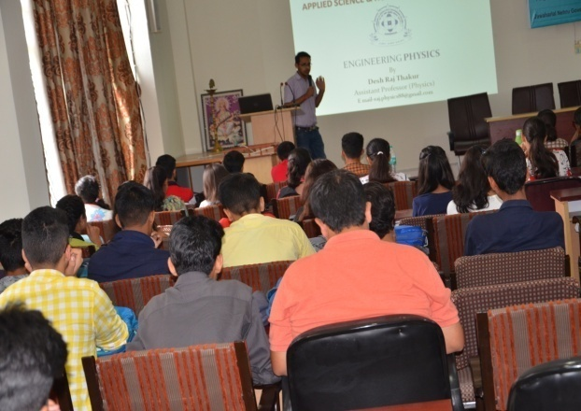

NATIONAL CADET CORPS
NCC Jawaharlal Nehru Govt. Engineering College (JNGEC) was established in July, 2016 under the 2HP BN NCC Mandi.The sanctioned strength of NCC Unit is 50 cadets (Fifty Cadets). Captain H.S Rana is NCC Officer. He is Awarded Best NCC Officer in the state in 2002 & 2012 and also awarded with DG Commendation in 2015.
MOTO OF NCC :- UNITY AND DISCIPLINE
AIM OF NCC
To Develop Character, Comradeship, Discipline, Leadership, Secular Outlook, Spirit of Adventure, and Ideals of Selfless Service amongst the Youth of the Country. To Create a Human Resource of Organized, Trained and Motivated Youth, To Provide Leadership in all Walks of life and be Always Available for the Service of the Nation. To Provide a Suitable Environment to Motivate the Youth to Take Up a Career in the Armed Forces.
PLEDGE
WE THE CADET OF THE NATIONAL CADET CORPS, DO SOLOEMNLY PLEDGE THAT WE SHALL ALWAYS UPHOLD THE UNITY OF INDIA. WE RESOLVE TO BE DISCIPLINED AND RESPONSIBLE CITIZEN OF OUR NATION. WE SHALL UNDERTAKE POSITIVE COMMUNITY SERVICE IN THE SPIRIT OF SELFLESSNESS AND CONCERN FOR OUR FELLOW BEINGS.
Engineers Day, Teachers Day, Independence Day, Republic Day, Annual day (TWASK), Sports meet, were organized in the institute

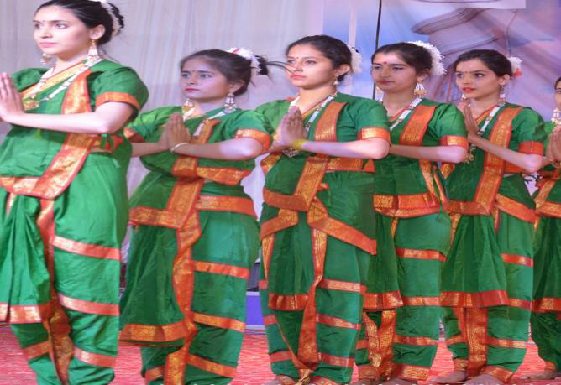

- Awards/Prizes won by students, faculty
Sr No | Name of event | Name of Students | Name of Product | Date of Event | Venue | Position Held
1 | Startup Fest | Deepak Sharma & Team, Final year Mechanical (2018 pass out) | Combined Refrigration system | 09/04/2018 | DTE Sundernagar | Winner
2 | TechStar Startup Weekend powered by Google | Nitish Sharma and Team , Final year Textile | UV rays protected T shirt (Ternate Wears) | 14-16 September 2018 | JUIT Wakhnaghat Solan | First Prize

- Financial information: Funds received & Spent

